**Open-Source Intelligence and Penetration Testing Project Report**

Madelyn Wolf, Bassem Khalil, Siegfreid Halili, Jacob Roth, Ethan Ullberg

Information Technology, Arizona State University

IFT475: Security Analysis

Professor Gary Grindle

November 23rd, 2025

**Table of Contents**

**Executive Summary** 2

**Introduction** 3

**Scope** 4

**Details** 4

**Open-Source Intelligence** 4

**Company Profile:** 4

**Executive Leadership:** 6

**Financials:** 11

**Social Media:** 13

**Network:** 15

**Penetration Testing** 18

**Server 1:** 18

**Server 2:** 27

**Server 3:** 37

**Recommendations** 46

**Conclusion** 50

**Annexes** 51

**Annex A - References** 51

**Annex B – Acronyms** 52

**Annex C – Additional Images/Screenshots/Tables** 54

# **Executive Summary**

This project involved a comprehensive cybersecurity assessment of three simulated systems within the Apporto Modular Cyberlab environment using Kali Linux and industry-standard tools including Nmap, Enum4Linux, Nessus, and a Metasploit. The scope of the testing focused on identifying open ports, services used by the servers, and any potential vulnerabilities that could be compromised or exploited by an attacker. The penetration testing process consisted of network scanning, service enumerations, vulnerability assessment, and controlled exploit attempts in non-destructive exploit attempts.

The results showed variations in the level of security among the servers that were tested. Server one was very well secured; it was configured to serve as a Windows Active Directory Domain Controller and had robust authentication controls that effectively blocked attempts of any unauthorized enumeration and exploitation. Server two, however, presented considerable security concerns. It was identified as running outdated Ubuntu 8.04 operating systems with numerous open ports, misconfigured services, exposed NFS shares, weak access controls, and multiple critical vulnerabilities confirmed by Nessus and Metasploit. These findings indicate that Server 2 is highly accessible to unauthorized users. Server three was the least secure server out of all of them. Serious weaknesses, with outdated software and overly exposed services that made the system vulnerable to possible exploits and attacks. Overall analysis indicates that there are some systems that are appropriately hardened, while others require immediate attention. Key recommendations include upgrading systems to the most recent versions that are supported, enforcing stronger authentication mechanisms, allowing only authorized users access to the system based on their needs, minimizing exposed services, and improving patch management.

In conclusion, the assessment confirms that enhanced hardening of the servers along with consistent maintenance and updates is crucial in rendering the overall resilience of the servers and the network environment.

# **Introduction**

This report examines CarGurus, a midsize public company in the online automotive marketplace industry. As a technology-driven organization with a large user base and a highly visible digital footprint, CarGurus provides a realistic setting for understanding how public information and technical weaknesses can influence an organization’s overall security risk.

The assessment draws from open-source intelligence (OSINT) techniques that were used to review the company’s publicly accessible information, including corporate materials, financial disclosures, leadership profiles, and social media activity. Third-party data broker websites were also used to gather more personal information on the leadership team. This information provides a better understanding of CarGurus’ structure, operations, and digital footprint, which are all factors that can influence reconnaissance efforts and increase the attack landscape. These findings are paired with observations from a simulated penetration testing lab environment. This controlled setting demonstrates how an attacker might leverage publicly available data to support technical enumeration, identify weaknesses, or enhance exploitation strategies and offers hands-on insight into how real-world attack patterns may unfold.

The OSINT research and penetration testing activities provide a combined view of CarGurus’ potential risk exposure. The sections that follow outline the company profile, financial overview, executive leadership, social media presence, and network information, followed by an analysis of relevant threats and recommendations for improving security posture determined through a simulated lab environment.

# **Scope**

The scope of this report covers OSINT techniques and tools including Google Hacking and CentralOps.net, as well as Servers One, Two, and Three in the simulated lab environment. Within the lab environment, each Server was tested using Nmap, Enum4Linux, Nessus, and Metasploit.

# **Details**

This section will cover the findings from the open-source intelligence gathering, as well as the Servers within the simulated lab environment.

## **Open-Source Intelligence**

### **Company Profile:**

CarGurus, Inc. is a publicly traded online automotive marketplace headquartered in Cambridge, Massachusetts. The company was founded in 2006 by Langley Steinert, who is also the co-founder of TripAdvisor, and is one of the most visited digital platforms for buying and selling new and used vehicles in the United States, with additional operations in Canada and the UK. On average, the company’s website receives nearly 43 million users every month (CarGurus, 2024). Its core business model centers on connecting consumers with dealerships through a listings marketplace that evaluates vehicle prices, dealer reputation, and market competitiveness using proprietary algorithms.

The organization expanded its portfolio through acquisitions including Autolist in 2020 and CarOffer in 2023, increasing its market share across both consumer-facing and dealer-focused vehicle commerce sectors (CarGurus, 2020; CarGurus, 2023). CarGurus employs approximately 1,250 staff, making it a mid-sized company with significant national and global reach. Eighteen months after the acquisition of CarOffer, CarGurus.com chose to shut down CarOffer after they had displayed three consecutive years of net losses. Many employees previously employed at CarOffer were laid off and forced to seek other forms of employment. An employee dissatisfied with this choice could easily become an insider threat as they have a greater understanding of the company’s inner workings than a layman. Leveraging their either current or former position within the organization, an employee could, using the correct set of tools, perform any number of malicious actions to harm CarGurus. This could come in many forms, such as implanting malware onto the company’s network, exfiltrating sensitive data through either a peripheral, like a USB drive, or to a device outside the network, and participating in a coordinated social engineering attack like phishing or spear-phishing. Additionally, a disgruntled employee could take the drastic approach and destroy network architecture, further disrupting operations for the business.

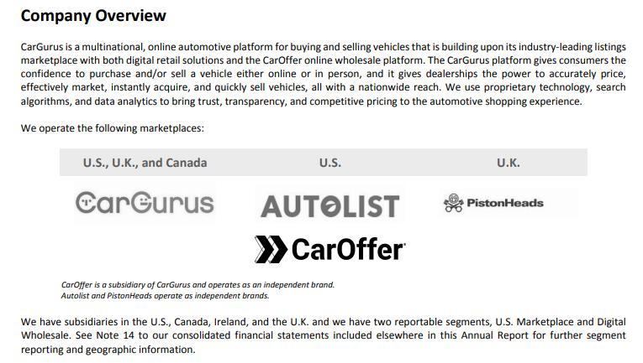

Figure 1: Company Overview Section of 2024 Annual Report

Since it is a publicly listed company, CarGurus maintains detailed financial disclosures, governance documentation, and leadership information through its investor relations site and Securities and Exchange Commission (SEC) filings. Executive biographies, leadership history, and organizational structure are publicly available on their main website, providing clear visibility into operational roles and business hierarchy. The company’s online presence extends across multiple domains, including its primary website, investor portal, and social media platforms such as LinkedIn, Instagram, X/Twitter, Facebook, and YouTube. These platforms showcase company announcements, executive communications, product updates, and internal culture highlights.

CarGurus’ combination of digital services, cloud-based infrastructure, multi-brand ecosystem, and extensive public-facing communication creates a diverse operational environment. This environment, while enabling transparency and customer engagement, also results in a publicly observable organizational and technical footprint that is relevant when assessing security posture and overall risk exposure.

### **Executive Leadership:**

CarGurus’ executive leadership team is composed of experienced individuals who oversee the company’s strategic, operational, technical, and financial functions. The leadership structure is publicly documented through company resources, investor filings, and professional profiles. Each executive maintains a public LinkedIn profile, as well as personal X/Twitter and Instagram accounts.

Langley Steinert, the company’s Founder and Executive Chairman, continues to play a significant role in guiding long-term strategy. As of 2024, after selling nearly six million dollars of his stake, he retains 907,057 shares and indirectly owns 52,593 (TradingView, 2024). Public data-broker sites such as TruePeopleSearch contain a substantial amount of personal information about Steinert that can be accessed for free, including previous and current residential addresses, phone numbers, associated email accounts, and the names of possible relatives. While this information is collected from public sources, its consolidation in a single location reduces the effort required for a malicious actor to conduct an attack. As the founder and Executive Chairman, Steinert’s proximity to strategic decision-making makes him a high value target for social engineering, extortion attempts, or identity-based attacks. The availability of address histories and family relationships also increases the feasibility of targeted social engineering scenarios that leverage personal familiarity, threatening messages, or impersonation of relatives. This exposure of Steinert’s personal data widens the potential attack surface by enabling threat actors to create highly convincing, personalized pretexts aimed at influencing company leadership or staff.

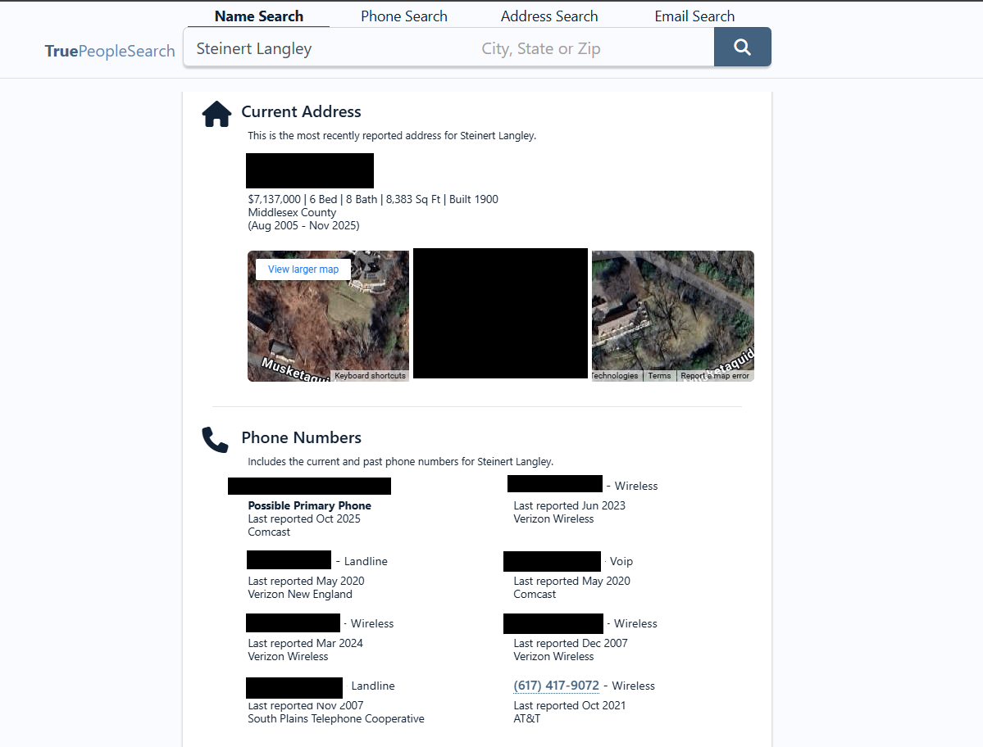

Figure 2: True people search results for Steinert (data blocked for privacy)

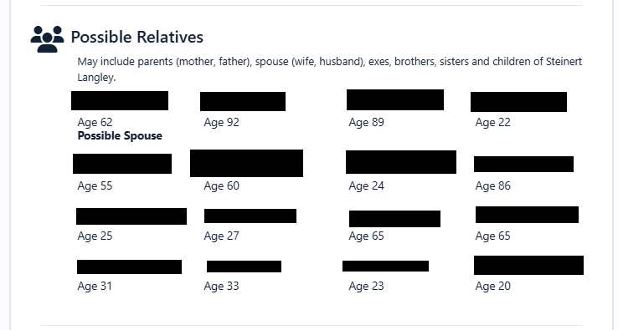

Figure 3: Relative information (data blocked for privacy)

Jason Trevisan, who joined CarGurus in 2015 as Chief Financial Officer and later transitioned to the role of Chief Executive Officer, is responsible for the company’s overall direction, performance, and organizational oversight. Like Steinert, TruePeopleSearch provides an abundance of personal data on Trevisan, including past and present addresses, contact information, and family members. As the current CEO and former CFO, Trevisan holds a central position of influence within the company’s financial and operational structure. The consolidated personal information can enable attackers to perform extremely credible spear-phishing attacks, executive impersonation attempts, or vishing campaigns that exploit knowledge of his identity or family network. Because Trevisan’s role involves oversight of financial approvals, strategic initiatives, and communications with investors, any attack that successfully leverages this personal data could lead to significant organizational compromise, such as fraudulent payment requests, disclosure of sensitive information, or manipulation of internal staff.

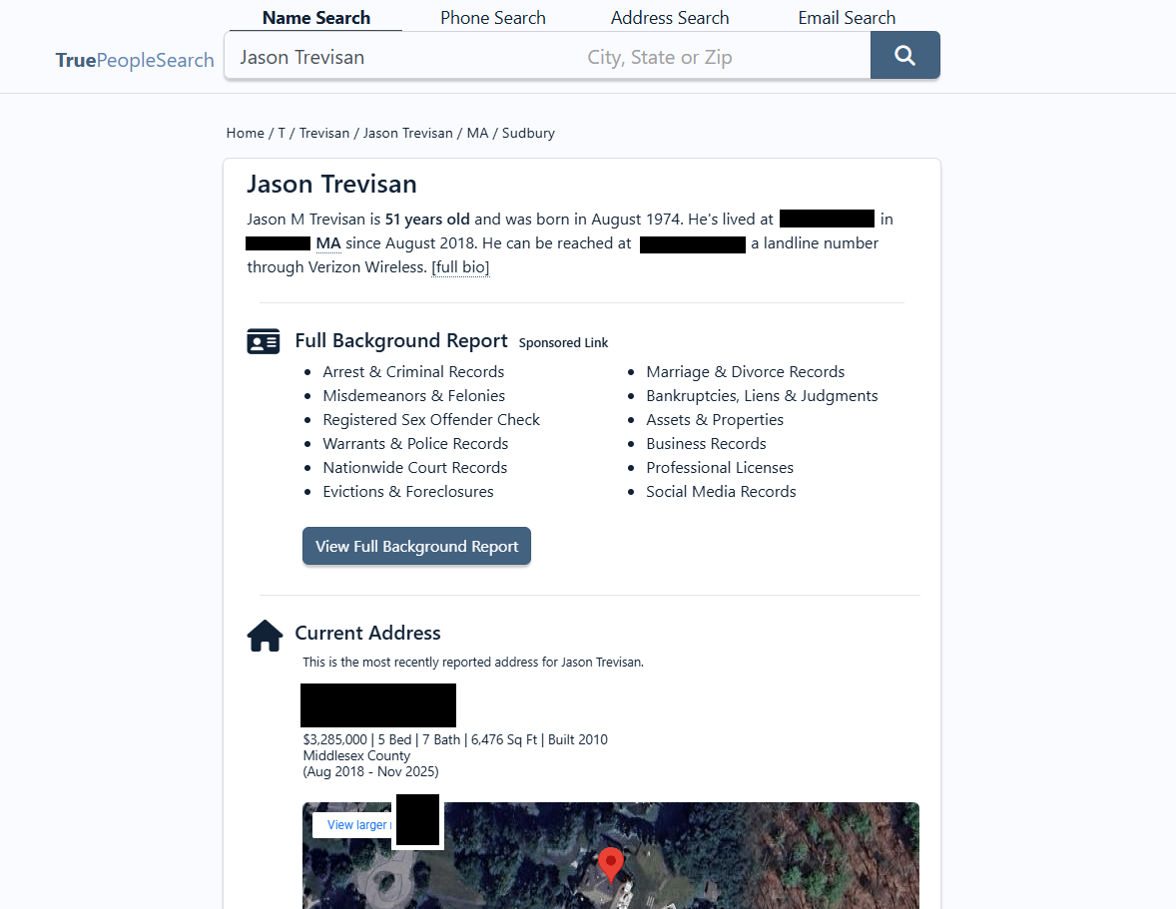

Figure 4: TruePeopleSearch results for Trevisan

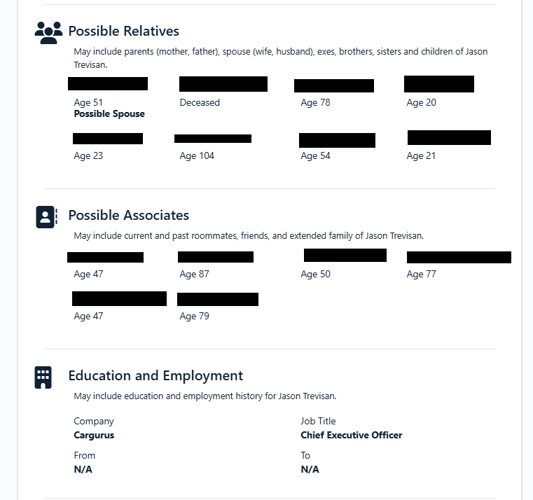

Figure 5: More TruePeopleSearch results for Trevisan

Supporting the executive team are several key leaders who manage core operational and technical areas. Sam Zales, President and Chief Operating Officer, oversees day-to-day operations and business execution. Matt Quinn, Chief Technology Officer, directs the organization’s engineering and technology strategy. Javier Zamora, Chief Legal Officer and Corporate Secretary, manages compliance, legal risk, and corporate governance. The financial function was previously led by Elisa Palazzo as the Chief Financial Officer but no longer works at the company as of March 2025. Per the company’s leadership page, Mike O’Hanlon is the current Chief Revenue Officer, but they have no information on a new CFO. The leadership team shapes the company’s strategic priorities and oversees major operational decisions, and their visibility through corporate communications, professional profiles, and other public-facing materials creates a clearly identifiable organizational hierarchy that is relevant when evaluating potential insider-threat or social engineering risks.

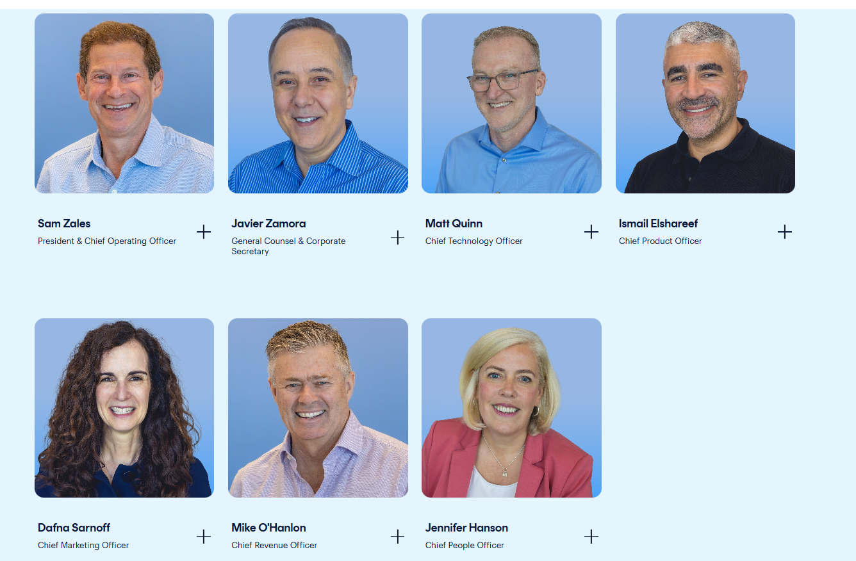

Figure 6: Executives at CarGurus

### **Financials:**

Comprehensive financial information is published directly by CarGurus through its annual reports, quarterly filings, and investor communications. As a publicly traded company, it maintains transparent reporting practices that outline its revenue sources, operating expenses, profitability, and overall financial health. Recent filings show that CarGurus generates much of its revenue through services offered to automotive dealerships, including advertising packages, listings, and tools designed to help dealers reach potential customers. Additional revenue is earned through its international operations and associated businesses (such as AutoList). The company maintains a stable financial position, with a consistent revenue of just under one billion dollars.

A notable security concern is the accessibility of CarGurus’ financial information. Many of these documents, such as compensation spreadsheets, performance graphs, and executive payment tables, are indexed by search engines and can be discovered through simple advanced search queries. For example, a Google search using the “filetype:xls” operator immediately reveals downloadable spreadsheets containing sections like “base salary,” “derivative securities,” and “executive compensation.” Combining the phrase “financials” and the “filetype:pdf” operator, reveals more financial information, including earnings reports, performance graphs, and historical pay data from multiple years. Because this information is published directly to the investor website, a malicious actor does not need to authenticate prior to viewing the information.

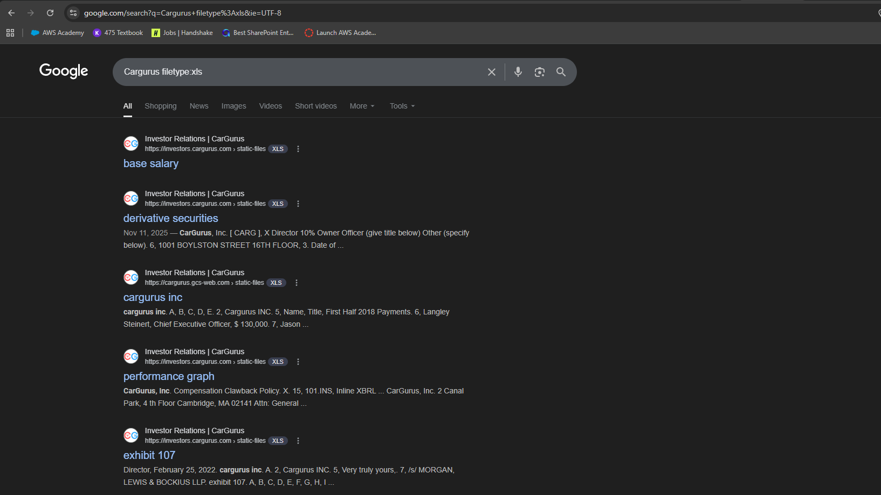

Figure 7: filetype:xls

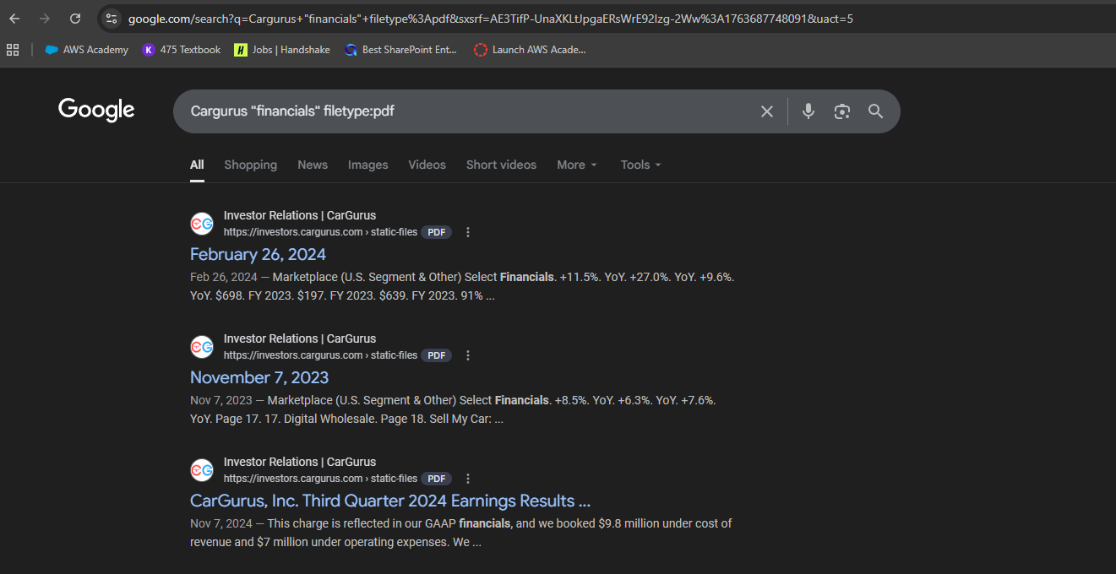

Figure 8: "financials" filetype:pdf

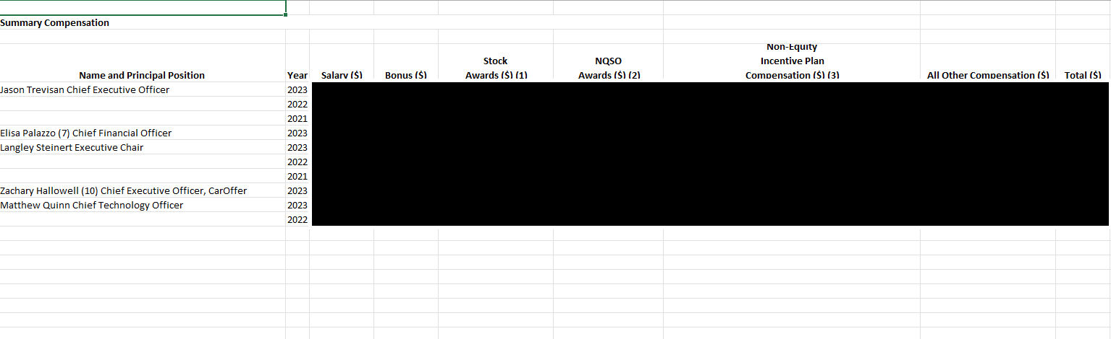

Figure 9: Internal spreadsheet with compensation information (data blocked out for privacy)

Such ease of access lowers the barrier for a malicious actor conducting reconnaissance. Sensitive insights like these enable attackers to create more convincing financial pretexts and target specific executives involved in fiscal operations. A lower-level employee could easily find the compensation information for the company’s executive leadership, potentially sparking anger and dissatisfaction with their own financial compensation, especially when compared to the base salaries, yearly/quarterly bonuses, and stock programs received by senior executives. This disparity can contribute to decreased morale and may increase the likelihood of insider-driven risks within the organization.

### **Social Media:**

CarGurus.com has an impressive social media presence spanning across platforms like Instagram, Facebook Meta, Twitter/X, and LinkedIn, reaching a wealth of viewers and followers. The company’s social media even expands to include members of their Executive Leadership teams, like Langley Steinert, the Founder and Executive Chairman to CarGurus.com, sharing personal accounts across these platforms and others. These profiles are publicly available and accessible, with Langley’s personal Instagram profile even being able to receive messages from other users. Posts to these platforms vary in their frequency, with their brand Facebook/Meta profile being the platform that gets posted to most frequently, often multiple posts within a day. The subject matter of these posts remains consistent across these platforms, often showcasing vehicle reports and guides, news about changes being made within the company or video content promoting the company’s services.

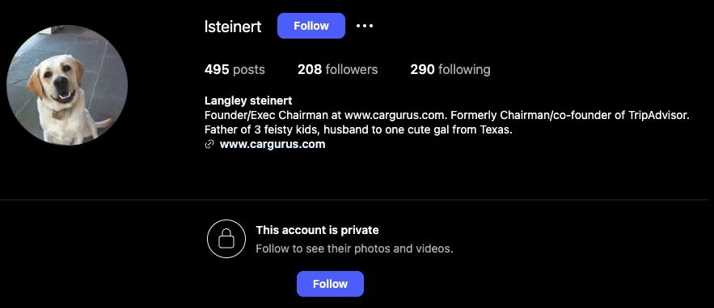

Figure 10: Langley Steinert Instagram

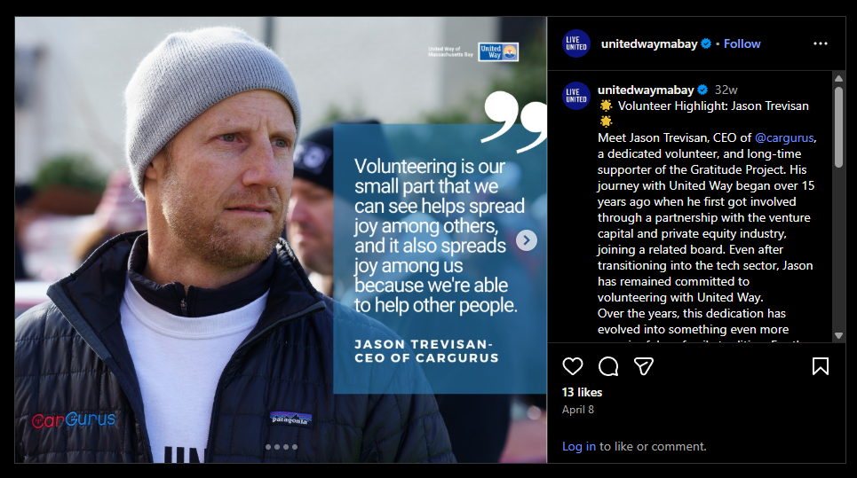

Figure 11: Instagram post featuring Jason Trevisan

### **Network:**

Through Open-Source Intelligence Gathering, we can gather a fair amount of data about CarGurus’s network configuration. This data was collected using footprinting tools like CentralOps.net and Netcraft.com, two sites which specialize in retrieving network information from a domain or IP address. By utilizing these tools, we can extract data to give us a better understanding of Cargurus’s network configuration. CentralOps.net was able to quickly provide us with the IP address of CarGurus.com, 151.101.161.91. Netcraft.com provided a different IP address for this domain, 199.232.25.91. This is likely due to Cargurus.com’s somewhat recent expansion into the eastern hemisphere in late 2025, as corroborating this information with the Shodan search engine, a search engine designed to discover and identify internet-connected devices, places this IP in Dublin, Ireland. IP information was not the only data CentralOps.net and Netcraft.com were able to provide. CentralOps.net was also able to provide us with information regarding the domain registrar, Godaddy.com. The domain registrar is the company responsible for managing the reservation of internet domain names as well as the assignment of IP addresses (Cloudflare, n.d.). Godaddy.com is the company that Cargurus.com purchased the URL of Cargurus.com from. Additionally, Centralops.net provided us with information regarding the DNS administrator for Cargurus.com, Amazon Web Services. In this context, Amazon Web Services or AWS, is the company responsible for ensuring that traffic intended for Cargurus.com is directed to their site. CentralOps.net also provided us with a registrar abuse contact information. This contact information is used by the public to report malicious activity to the registrar organization, Fastly Inc in the case of CarGurus.com, regarding the domain such as malware or suspicious activity on the site. The site also features Secure Socket Layer or SSL security protocols. This cryptographic protocol provides communication security over the internet.

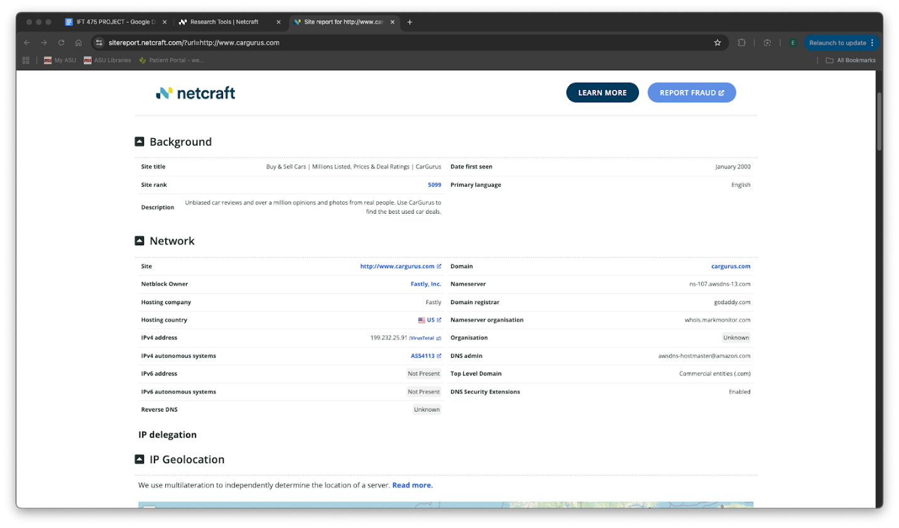

Figure 12: Information gathered from Netcraft.com

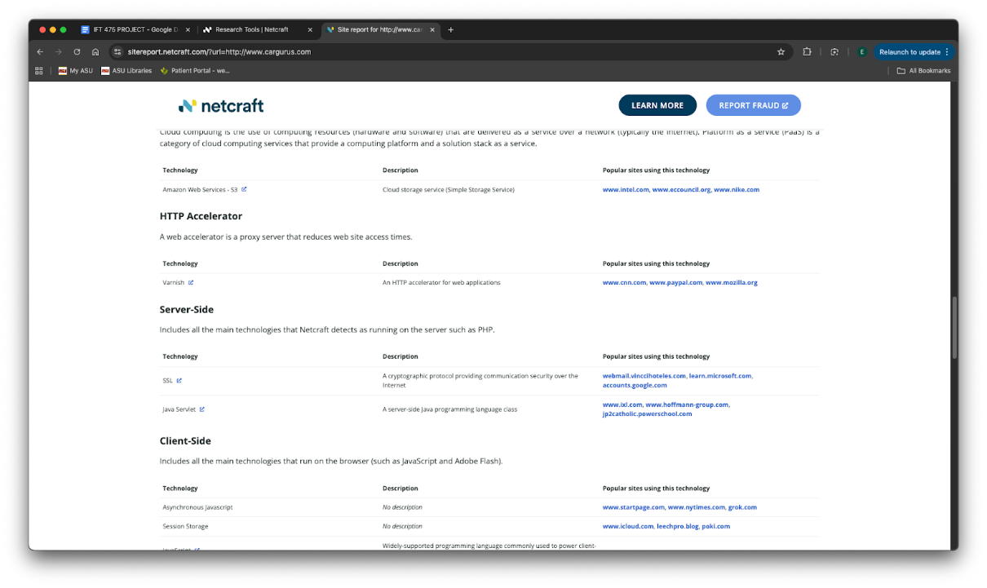

Figure 13: Information gathered from Netcraft.com (cont.)

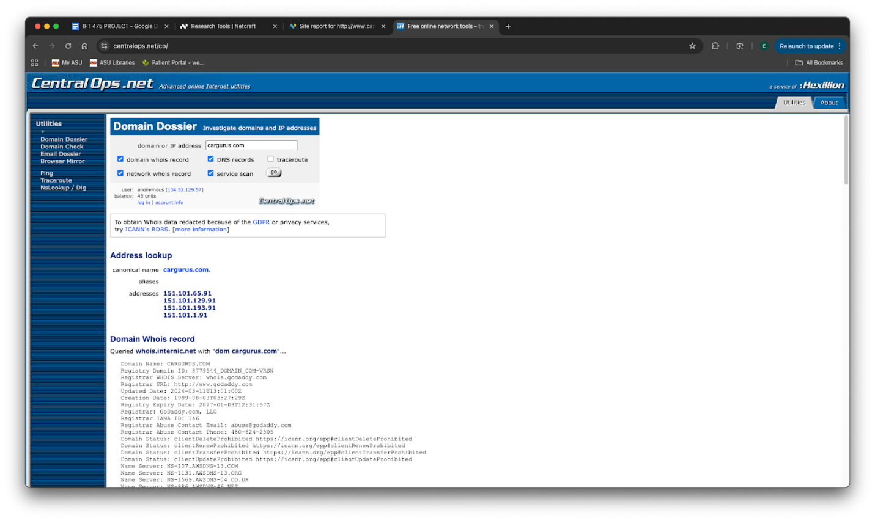

Figure 14: Information gathered from CentralOps.net

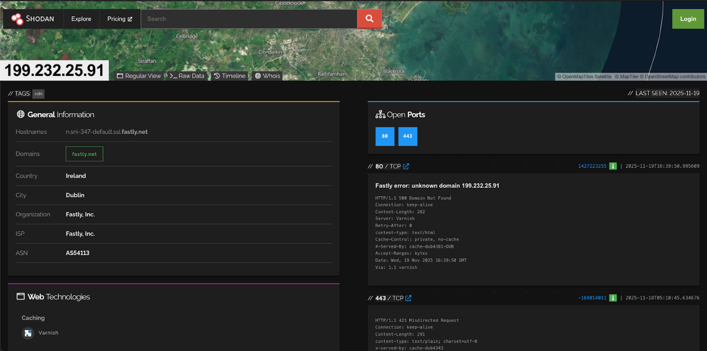

Figure 15: Shodan corroboration for the 199.232.25.91 address denoting its location in Dublin, Ireland.

## **Penetration Testing**

### **Server 1:**

A structured vulnerability assessment of Server1 was carried out using the following four primary tools in this phase of the project: Nmap, Enum4Linux, Nessus, and the Metasploit Framework. The overarching goal of this assessment was to identify potential security weaknesses and evaluate the system's overall resilience against common reconnaissance and exploitation techniques.

Initial reconnaissance was conducted with Nmap. Several scan types were run, including SYN, Connect, NULL, and XMAS scans, to get a full picture of the services available on the server. These scans revealed multiple open ports: 42 (Name), 80 (HTTP), 88 (Kerberos), 135 (RPC), 139 (NetBIOS), 389 (LDAP), 445 (SMB), 464 (kpasswd), 593 (RPC over HTTP), 636 (LDAPS), 3268 (Global Catalog), and 3269 (Global Catalog SSL). This service combination is typical of a Windows Server that has been configured to serve as an Active Directory Domain Controller, and this informed the course of the remainder of the testing.

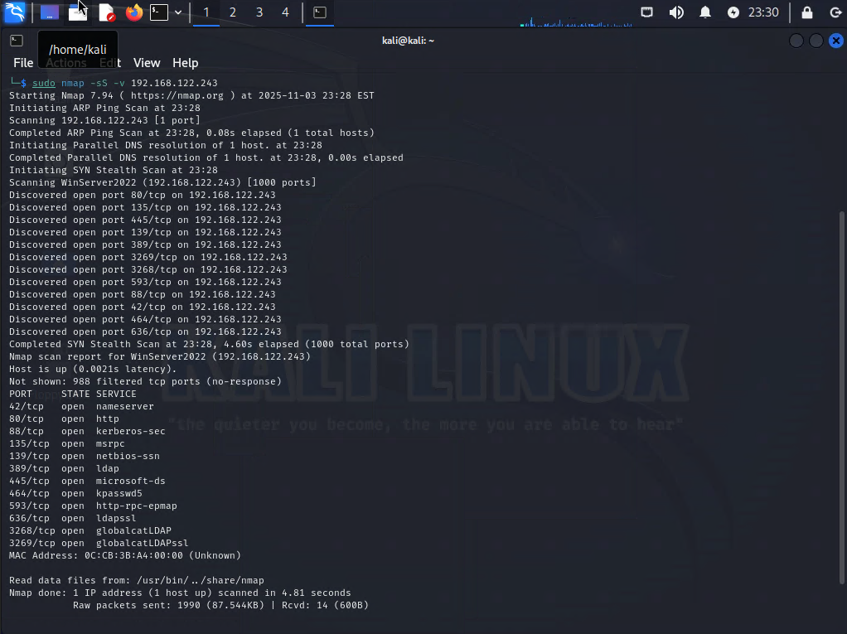

Figure 16: SYN scan (nmap -sS -v 192.168.122.243)

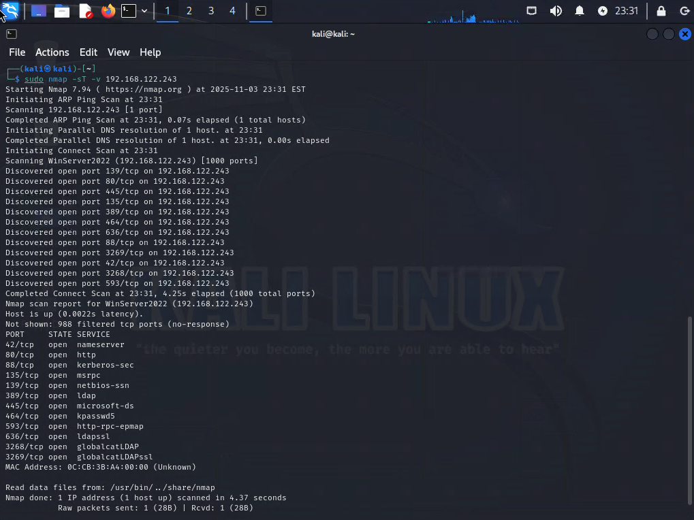

Figure 17: Connect scan (nmap -sT -v 192.168.122.243)

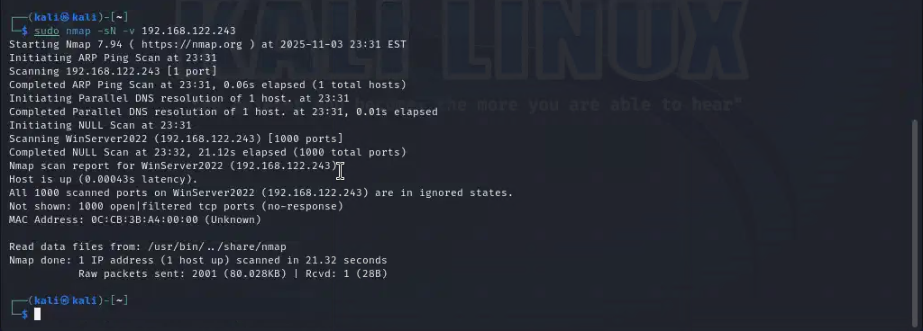

Figure 18: NULL scan (nmap -sN -v 192.168.122.243)

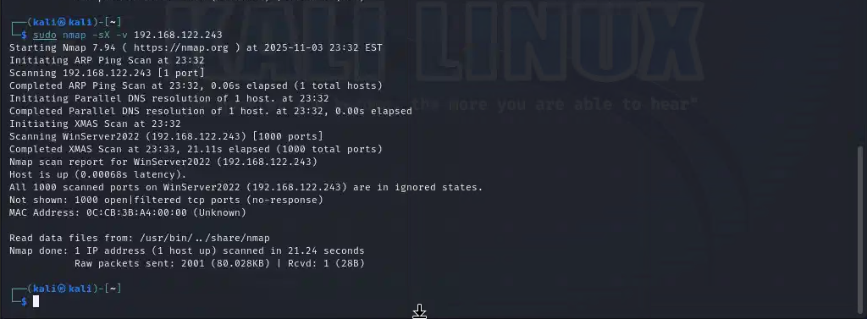

Figure 19: XMAS scan (nmap -sX -v 192.168.122.243)

Further enumeration was done using Enum4Linux. This tool attempted to retrieve SMB shares, user listings, NetBIOS information, and domain-level metadata. In every case, Server1 enforced the requirement for authentication, thereby disallowing anonymous access to these resources. Anonymous SMB logins, null sessions, and guest-based enumerations did not work. These findings together show that the server is very well secured against unauthenticated enumeration, thus eliminating one of the most common early-stage vectors attackers use to map domain structures.

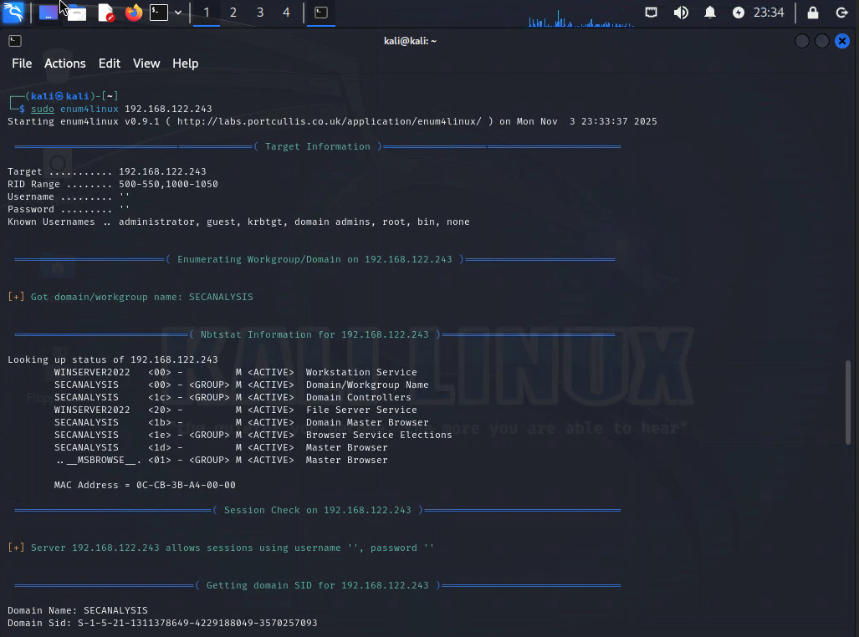

Figure 20: Sudo enum4linux 192.168.122.243

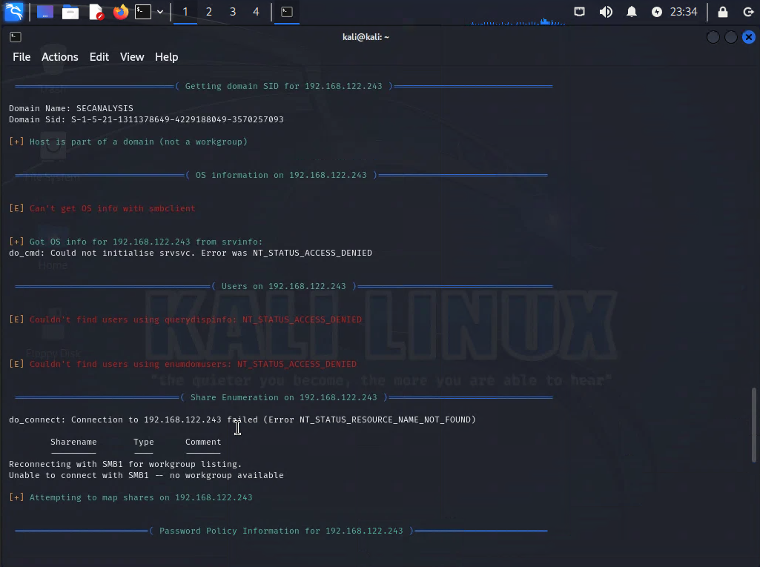

Figure 21: Sudo enum4linux 192.168.122.243

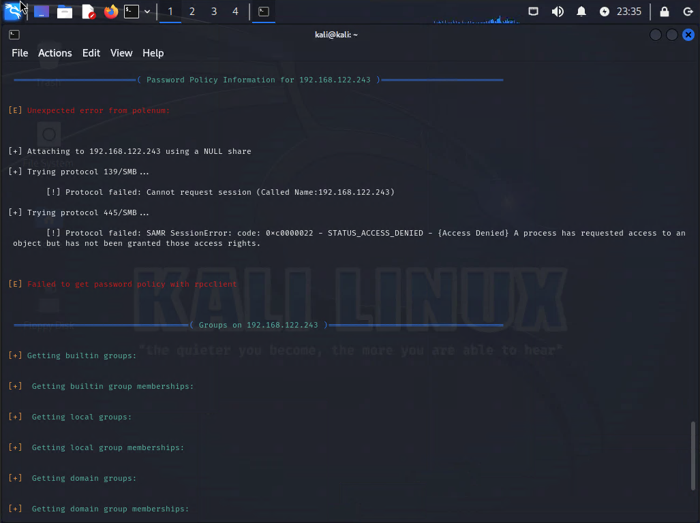

Figure 22: Sudo enum4linux 192.168.122.243

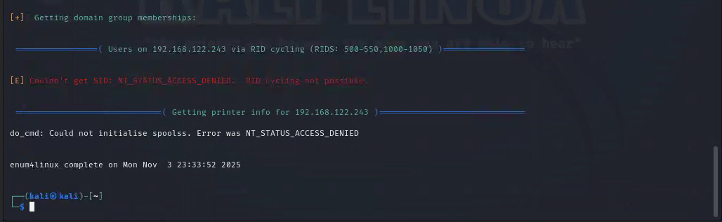

Figure 23: Sudo enum4linux 192.168.122.243

A Nessus vulnerability scan was conducted, and known vulnerabilities, as well as weak system configurations, were found. Nessus provided only informational findings that were general guidance in system hardening. Importantly, no critical, high, medium, or low-severity actionable vulnerabilities were found. The result indicates that Server1 is relatively well-maintained and follows security best practices, particularly for a system serving as a domain controller.

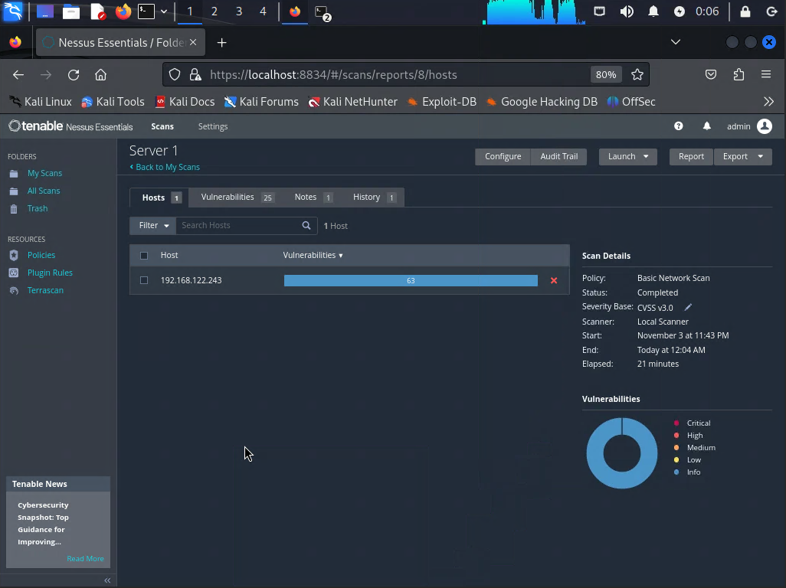

Figure 24: Nessus scan results

Since there were exposed services, Metasploit testing was conducted to see if any of them could be exploited. Various auxiliary modules tested SMB, LDAP, Kerberos, NetBIOS, RDP, and other exposed services. All attempts to interact with these services without valid credentials were rejected, with responses such as "authorization required" or "access denied." SMB operations required legitimate credentials, LDAP interactions were blocked without authentication, Kerberos requested valid user principals or tickets, and RDP login was prohibited even though the service was detectable. No anonymous FTP services were available. These results indicate that Server1 effectively prevents unauthorized Metasploit-based reconnaissance and exploitation attempts.

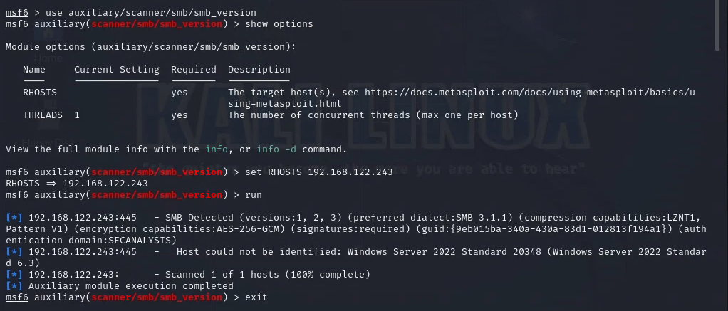

Figure 25: auxiliary/scanner/smb/smb_version

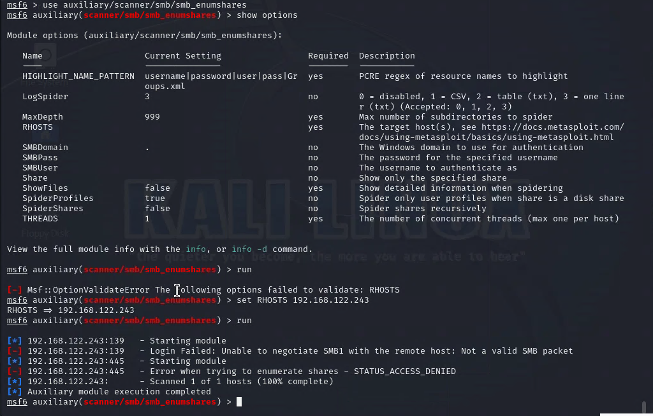

Figure 26: auxiliary/scanner/smb/smb_enumshares

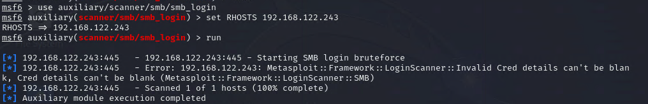

Figure 27: auxiliary/scanner/smb/smb_login

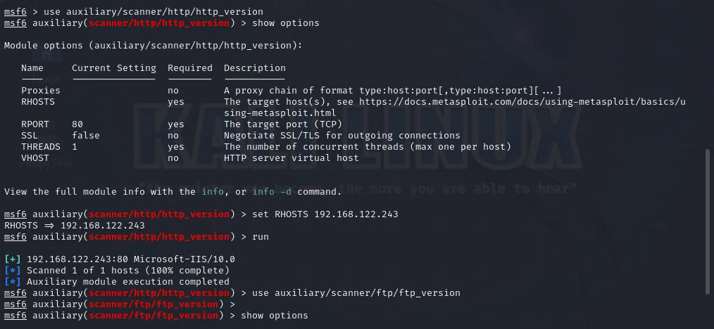

Figure 28: auxiliary/scanner/http/http_version

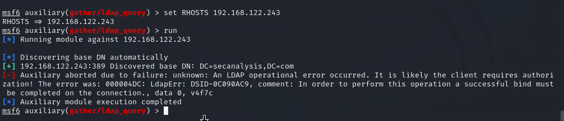

Figure 29: auxiliary/gather/ldap_query

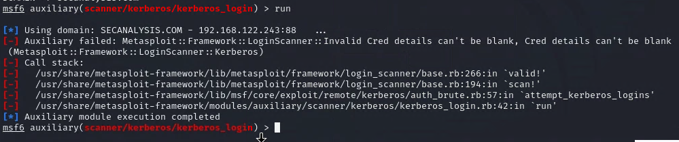

Figure 30: auxiliary/scanner/kerberos/kerberos_login

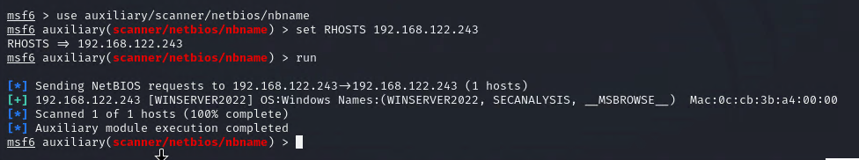

Figure 31: auxiliary/scanner/netbios/nbname

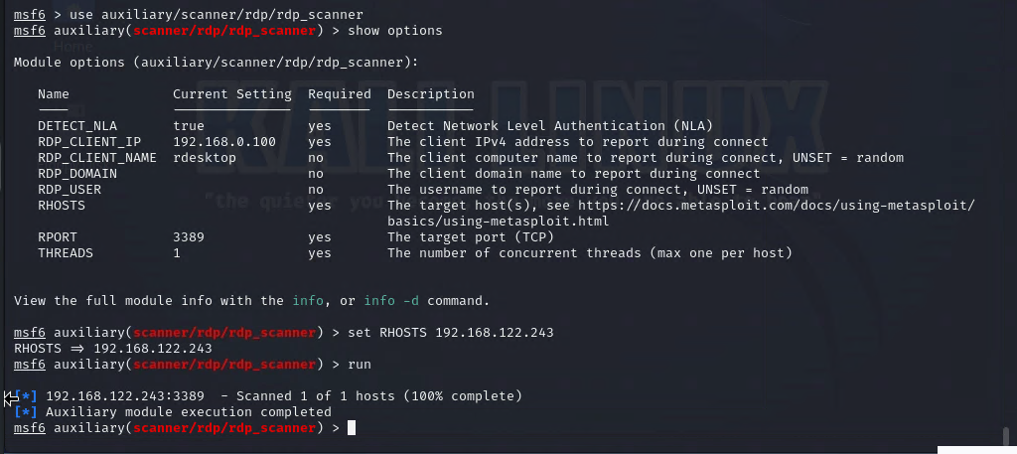

Figure 32: auxiliary/scanner/rdp/rdp_scanner

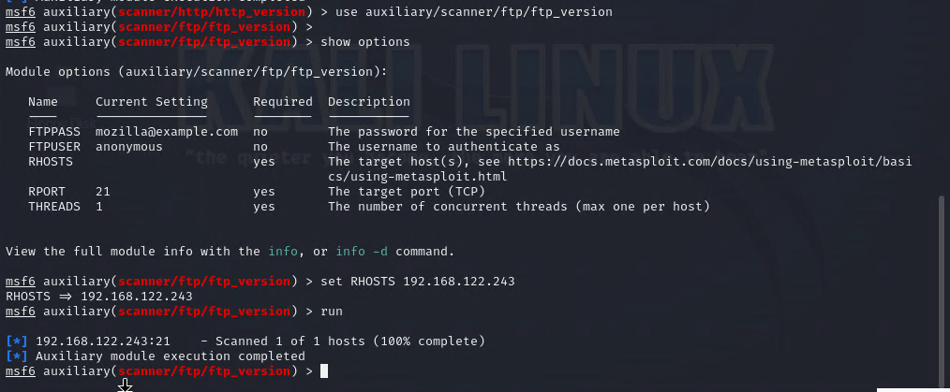

Figure 33: auxiliary/scanner/ftp/ftp_version

Overall, this test case suggests that Server1 is configured in a secure manner from the authentication layer, minimizing the possibility of unauthorized enumeration or exploitation. By disallowing unauthenticated access, Server1 eliminates many of the most commonly attacked vectors and limits the exposure of sensitive Active Directory information.

### **Server 2:**

The penetration tests that were conducted on Server 2 (192.168.122.44) served as a simulation of the real target in CarGurus’s system and showed a lot of critical information about the Company’s security exposure and current environment. This analysis combines all information gathered through Nmap, Enum4linux, Nessus and the additional scanning tool which was Metasploit based on group consensus. This pen test on server 2 shows an integrated understanding of the company’s vulnerabilities and potential attack surfaces.

The Nmap scans conducted on Server 2 showed the foundational source into the Company’s system network surface that is exposed to the outside world. The basic and targeted scans showed me multiple open ports that can mean being outdated or it was configured using insecure default settings. The OS detection revealed that Server 2 is just running a version of Ubuntu 8.04 LTS (Hardy Heron) which showed that it is a vulnerable machine. This information helped us use more enumeration and exploitation tools at our disposal. Nmap also identified open ports such as 80 HTTP, 22 SSH, 2049 NFS, 514 TCP, and 26 other open ports showing a lot of potential entry for attackers.

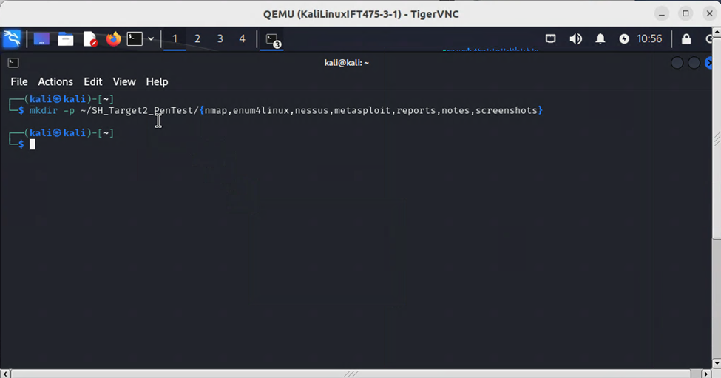

Figure 34: Mkdir -p

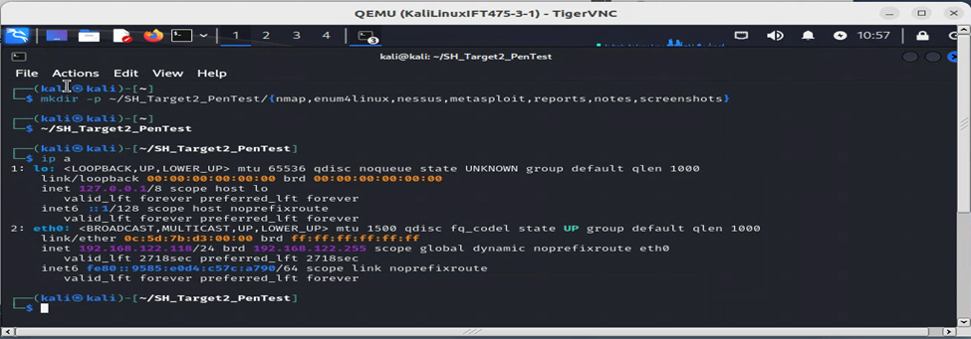

Figure 35: ip a

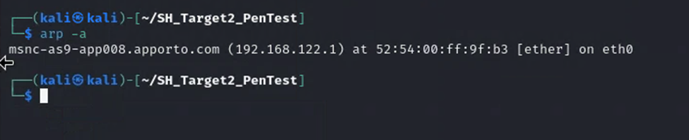

Figure 36: arp -a

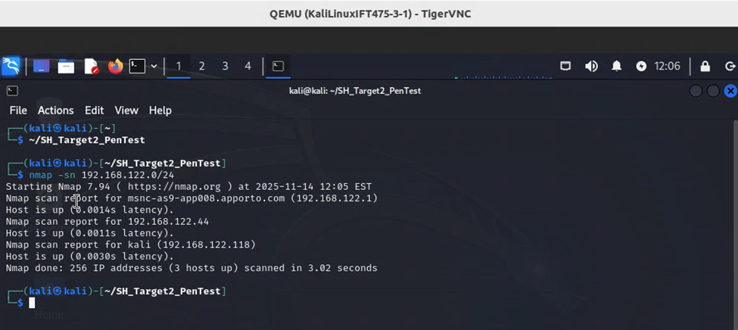

Figure 37: Nmap -sn 192.168.122.0/24

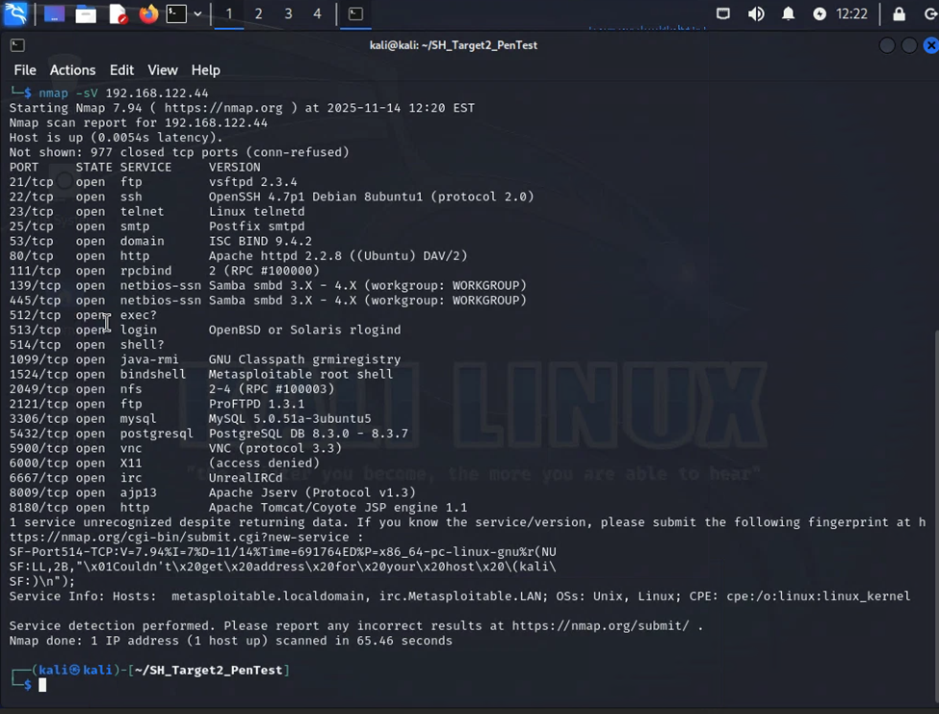

Figure 38: Nmap -sV 192.168.122.44

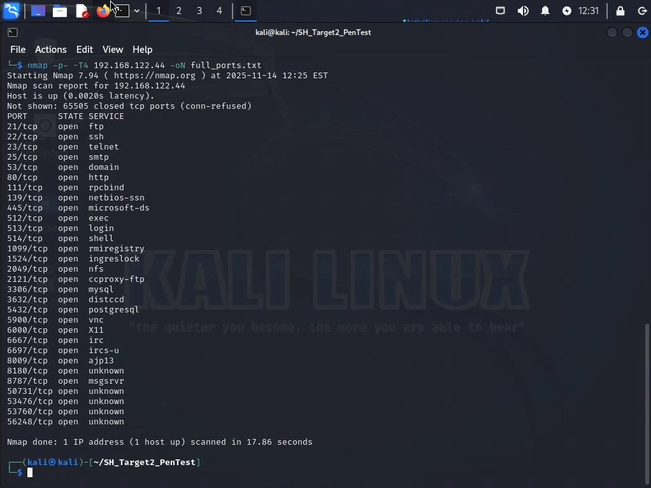

Figure 39: Nmap -p- -T4 192.168.122.44 -oN full_ports.txt

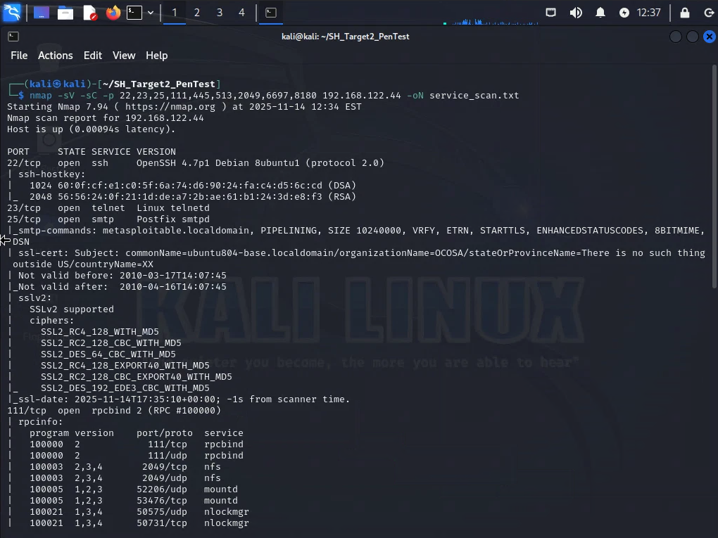

Figure 40: Nmap -sV -sC -p 22,23,25,111,445,513,2049,6697,8180 192.168.122.44 -oN service_scan.txt

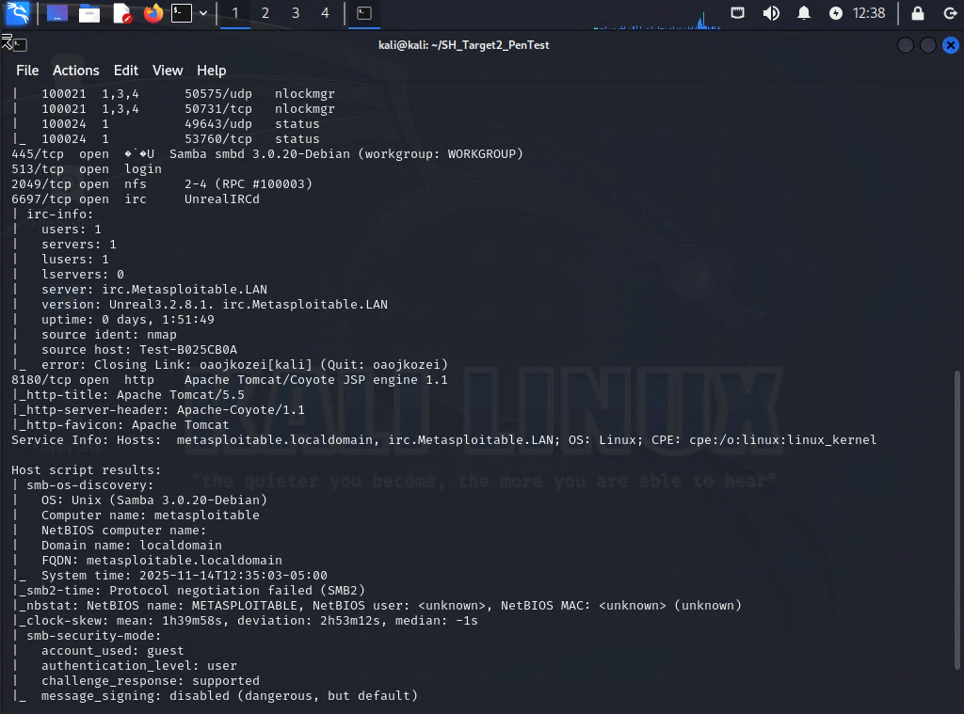

Figure 41: Nmap -sV -sC -p 22,23,25,111,445,513,2049,6697,8180 192.168.122.44 -oN service_scan.txt



Figure 42: Nmap -sV -sC -p 22,23,25,111,445,513,2049,6697,8180 192.168.122.44 -oN service_scan.txt

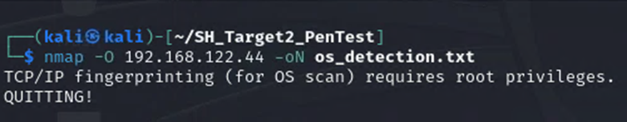

Figure 43: Nmap -O 192.168.122.44 -oN os_detection.txt

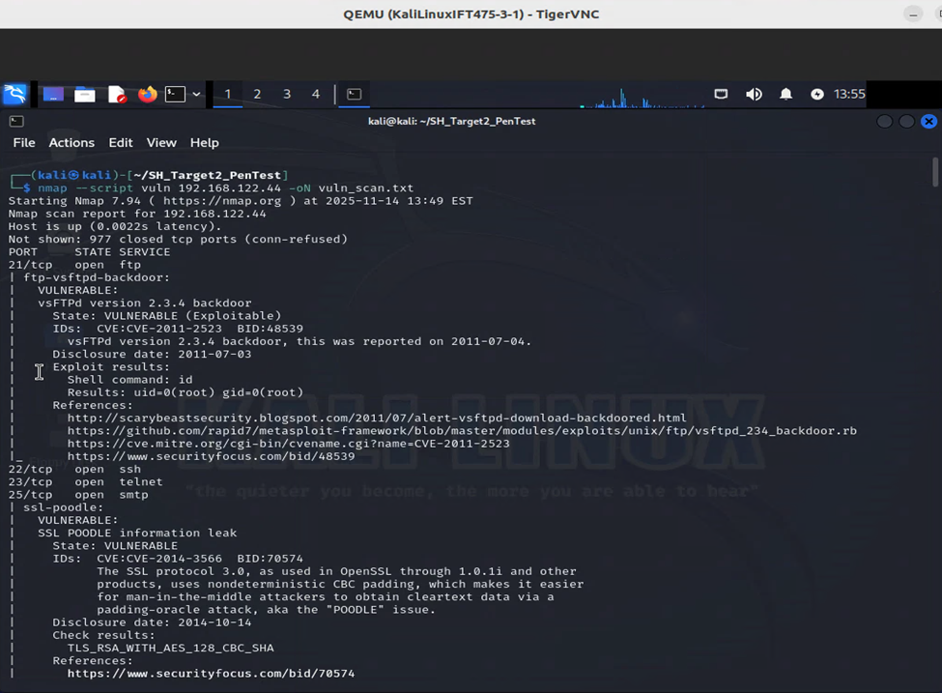

Figure 44: nmap –script vuln 192.168.122.44 -oN vuln_scan.txt

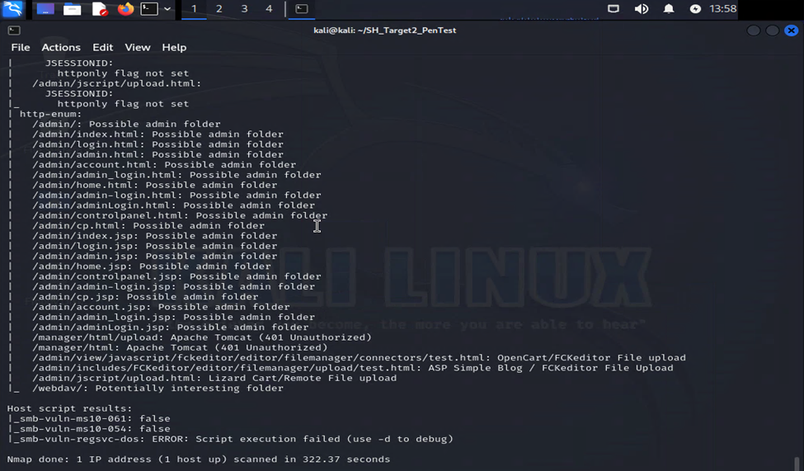

Figure 45: nmap –script vuln 192.168.122.44 -oN vuln_scan.txt

The Enum4linux scan showed us very detailed enumeration of CarGuru’s user accounts, SMB services, network shares, and even Windows domain information. By getting the username information the risk of using  brute-force attacks is increased. Insider threats are also heightened because permissions are improperly configured in the system. It is safe to assume that even the password policies are poorly enforced or weak thus attackers have another easier point of attack.

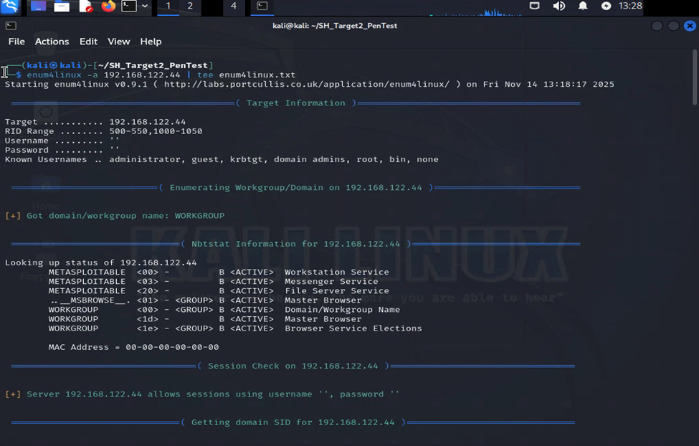

Figure 46: enum4linux -a 192.168.122.44 | tee enum4linux.txt

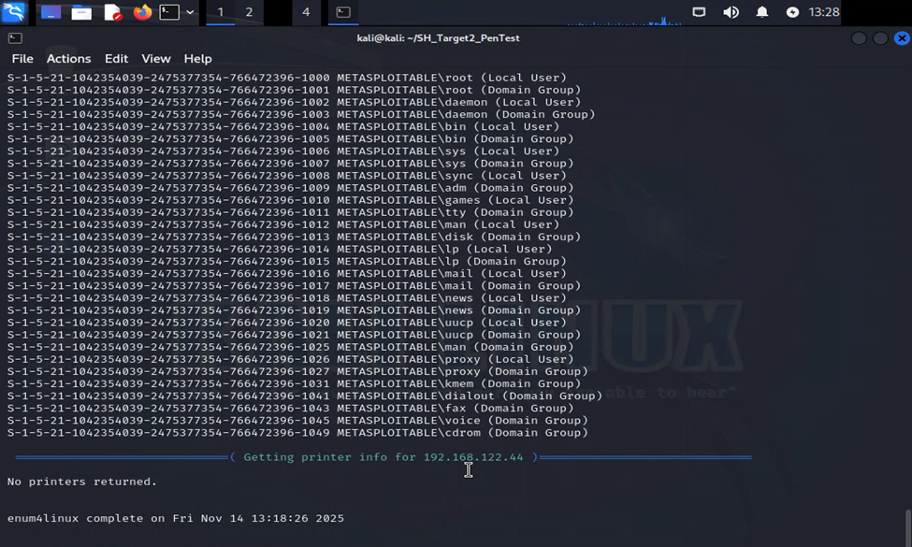

Figure 47: enum4linux -a 192.168.122.44 | tee enum4linux.txt

The Nessus scans provided us with a whole list of vulnerabilities ranging from low to critical! These vulnerabilities are weaknesses that an attacker could easily exploit. One such vulnerability is critical where at least one of the NFS shares exported by the remote server could be mounted by the scanning host and allows an attacker to leverage it to ready and even write the files on a remote host. Such an example of vulnerability shows that unauthorized access could lead to data exposure or even a full system wide takeover depending on the severity of the attack. The great thing about a Nessus scan is that a solution is provided with the vulnerability as well.

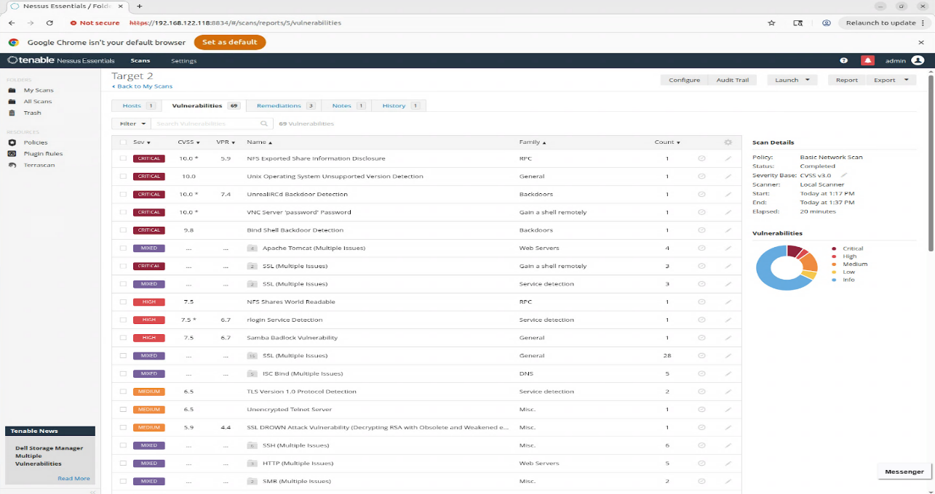

Figure 48: Server 2 Vulnerabilities

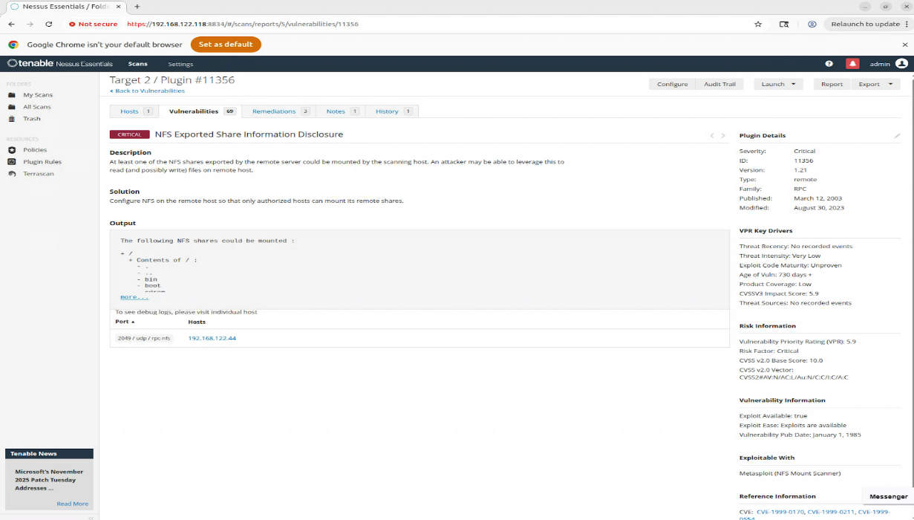

Figure 49: Server 2 NFS Exported Share Information Disclosure

The Metasploit scan was used to verify the vulnerabilities that were found by Nmap and Nessus. Metasploit searched exploitable service versions in the system. The presence of these exploitable modules shows a vulnerable system that could be enticing to possible attackers due to lack of protection that the system possesses.

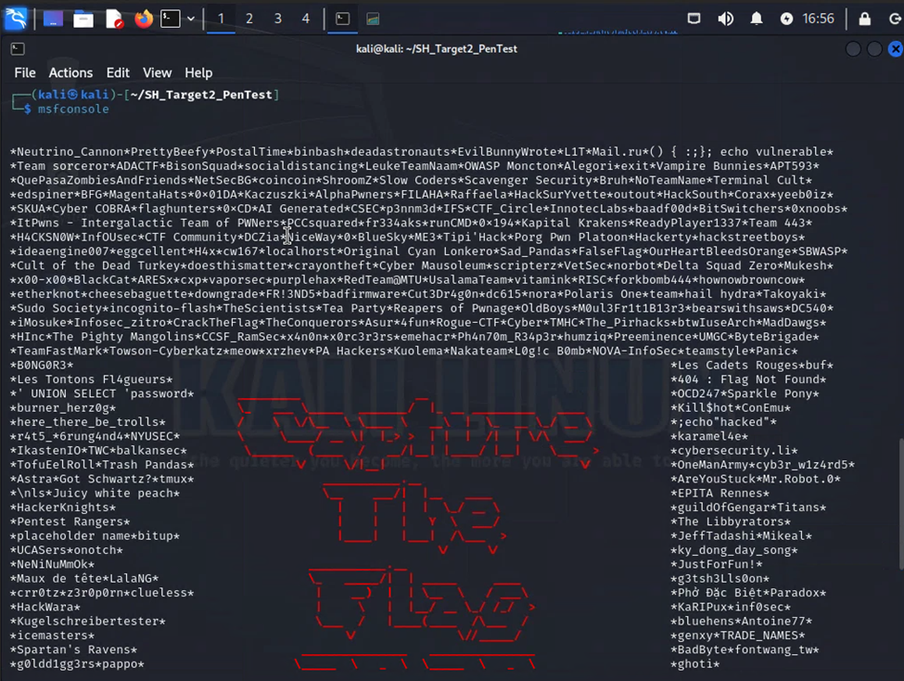

Figure 50: msfconsole

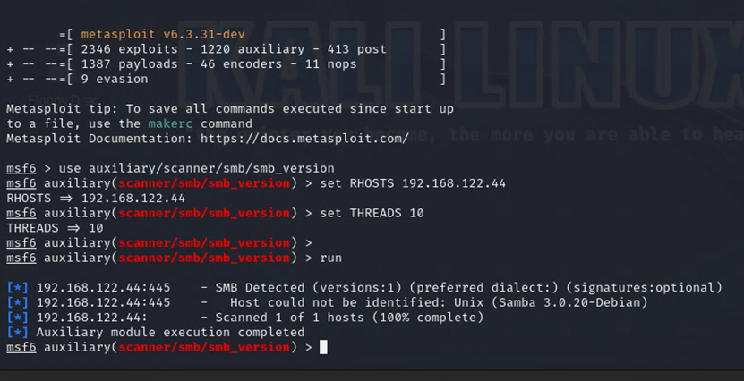

Figure 51: msfconsole

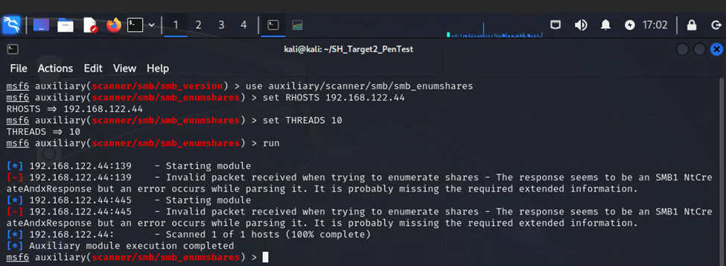

Figure 52: msfconsole

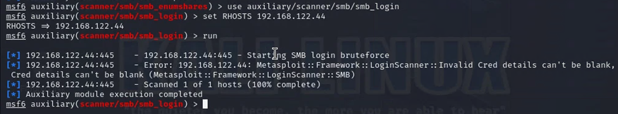

Figure 53: msfconsole

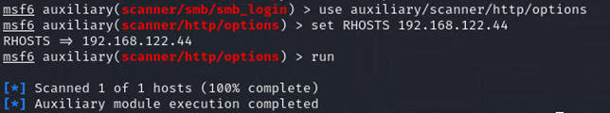

Figure 54: msfconsole

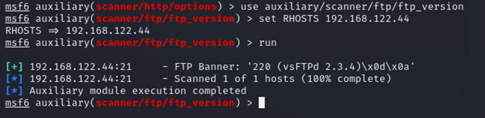

Figure 55: msfconsole

### **Server 3:**

The server is built on Windows Server 2008 R2, an end-of-life system with no current security updates from Microsoft. Four primary tools were used to assess the system. Nmap, Enum4linux, Nessus, and Nikto tools.

Nmap was used to identify exposed ports, active services, and general network behavior of the Windows Server 2008 R2 web application server. Four scan types SYN Stealth, TCP Connect, NULL, and XMAS were conducted to evaluate both open ports and how the server responded to various probes.

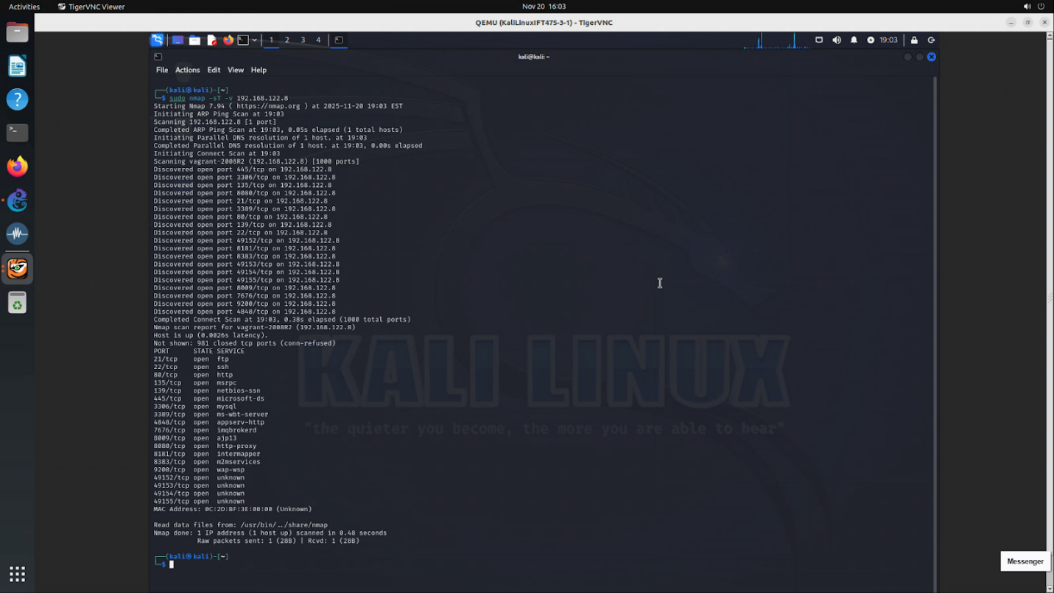

Figure 56: Connect Scan (sudo nmap -sT -v 192.168.122.8)

The TCP Connect Scan against 192.168.122.8 revealed a potentially very broad attack surface, with services running across a wide range of ports. SSH was open on port 22, confirming remote shell access is available on the system. Several web services were exposed, including standard HTTP on port 80, as well as additional web applications or frameworks running on ports 3000, 8080, 8081, and 8181. These ports indicate that multiple web-based interfaces or development services are active. The scan also identified SMB-related services on ports 135, 139, and 445, along with several Microsoft RPC dynamic ports in the 49152–49159 range. A MySQL database service was discovered on port 3306, which is significant since weak or default credentials on this service frequently lead to full system compromise.

Enum4linux was used to enumerate SMB-related information on the Windows Server 2008 R2 Web Application Server at 192.168.122.8. Since this host exposes SMB services on ports 139 and 445, enumeration was used to determine whether the server leaked information that could support authentication attacks, OS profiling, or privilege escalation.

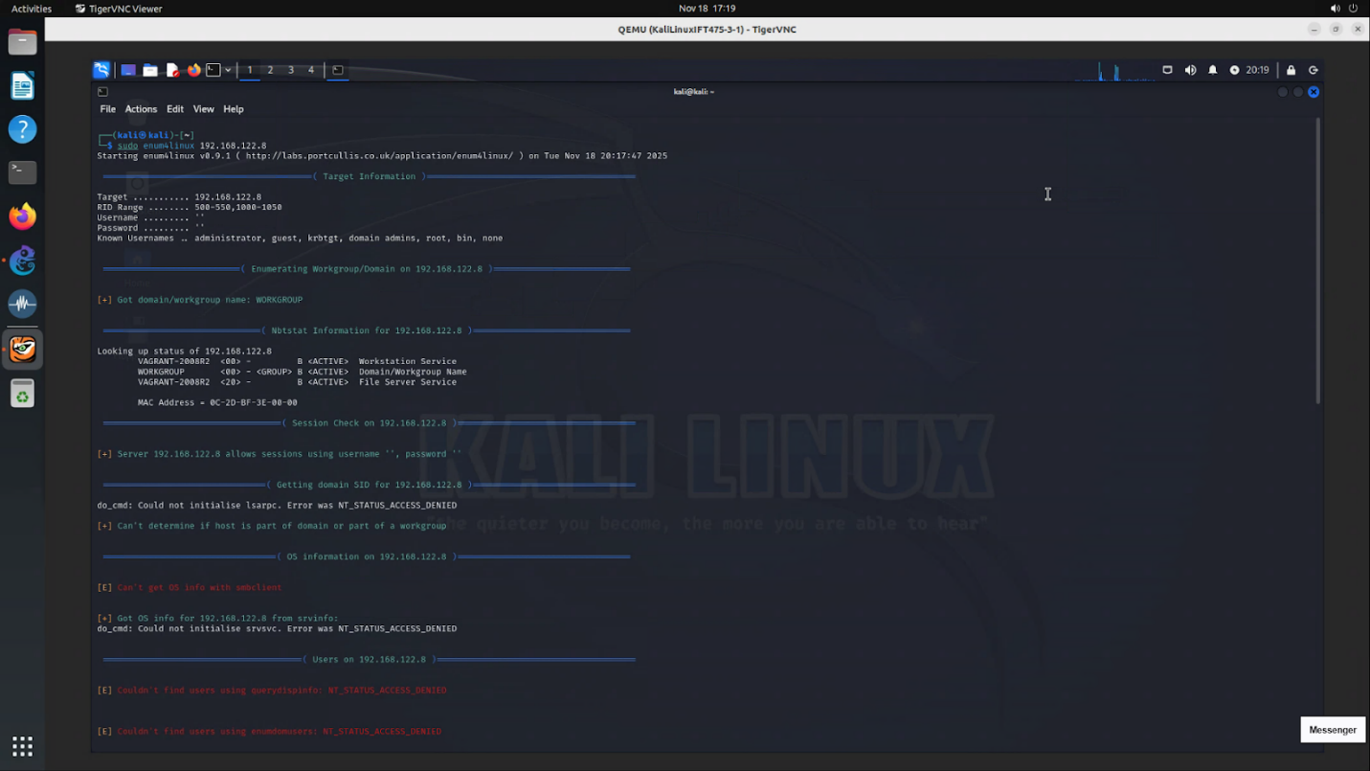

Figure 57: sudo enum4linux 192.168.122.8

The Enum4linux scan against the Windows Server 2008 R2 system at 192.168.122.8 shows that SMB services are active, but the server is heavily restricted when it comes to anonymous access. The tool was able to confirm the system’s workgroup name (WORKGROUP) and identify the host through NetBIOS, which verifies that SMB and related services are running. However, all attempts to gather meaningful information through a null session were blocked. Requests for OS information, SIDs, server details, or domain data consistently returned NT_STATUS_ACCESS_DENIED, which aligns with the default security posture of a properly configured Windows Server 2008 R2 system.

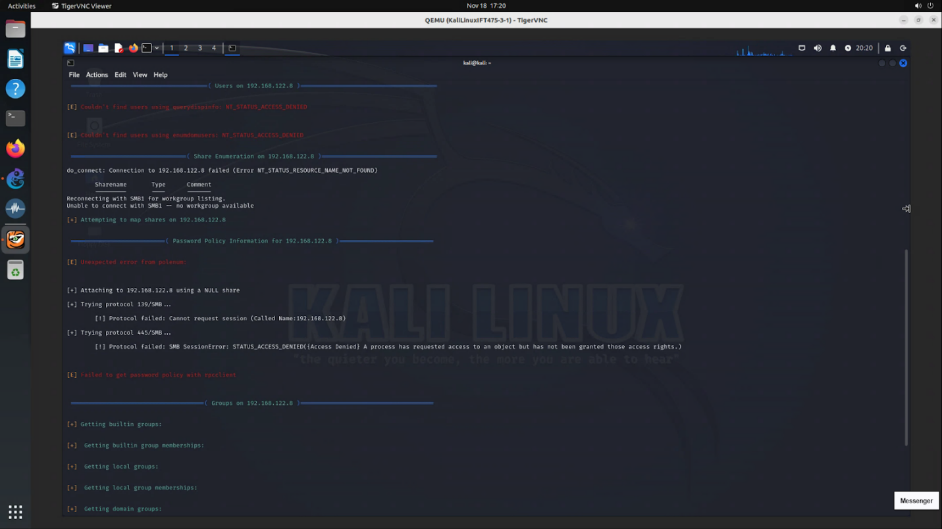

Figure 58: sudo enum4linux 192.168.122.8

Share enumeration attempts were also unsuccessful, with the server responding with NT_STATUS_RESOURCE_NAME_NOT_FOUND. Both SMB1 and SMB2 connection attempts through ports 139 and 445 were denied, preventing the tool from establishing any unauthenticated session. Password policy extraction failed for the same reason, and group or user enumeration did not return any results. Additional efforts, such as RID cycling and printer information queries, were also blocked, resulting in further access denied errors. Share enumeration attempts were also unsuccessful, with the server responding with NT_STATUS_RESOURCE_NAME_NOT_FOUND. Both SMB1 and SMB2 connection attempts through ports 139 and 445 were denied, preventing the tool from establishing any unauthenticated session. Password policy extraction failed for the same reason, and group or user enumeration did not return any results. Additional efforts, such as RID cycling and printer information queries, were also blocked, resulting in further access denied errors.

Nikto scans were run across multiple web services on the Windows Server 2008 R2 server, and the results showed a mix of outdated software, missing security headers, and weak default configurations. The HTTP service on port 80 was running IIS 7.5 with ASP.NET, and Nikto flagged missing headers like X-Frame-Options and X-Content-Type-Options, which are common on older IIS setups but still weaken security (OWASP, 2024).

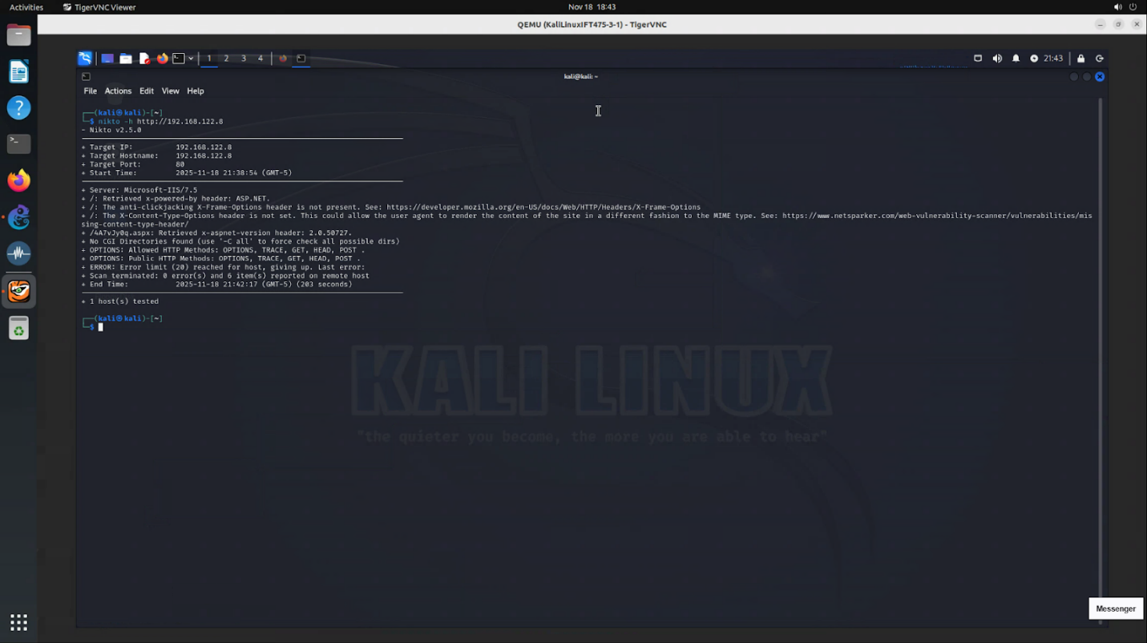

Figure 59: nikto -h <http://192>.168.122.8

The scans on ports 8080 and 8181 revealed that both were running GlassFish Server Open Source Edition 4.0, an older Java-based application server. GlassFish exposed even more issues. It allowed risky HTTP methods such as PUT, DELETE, and TRACE, and lacked basic security headers. These behaviors suggest the GlassFish instances are using default or poorly hardened configurations (OWASP, 2014).

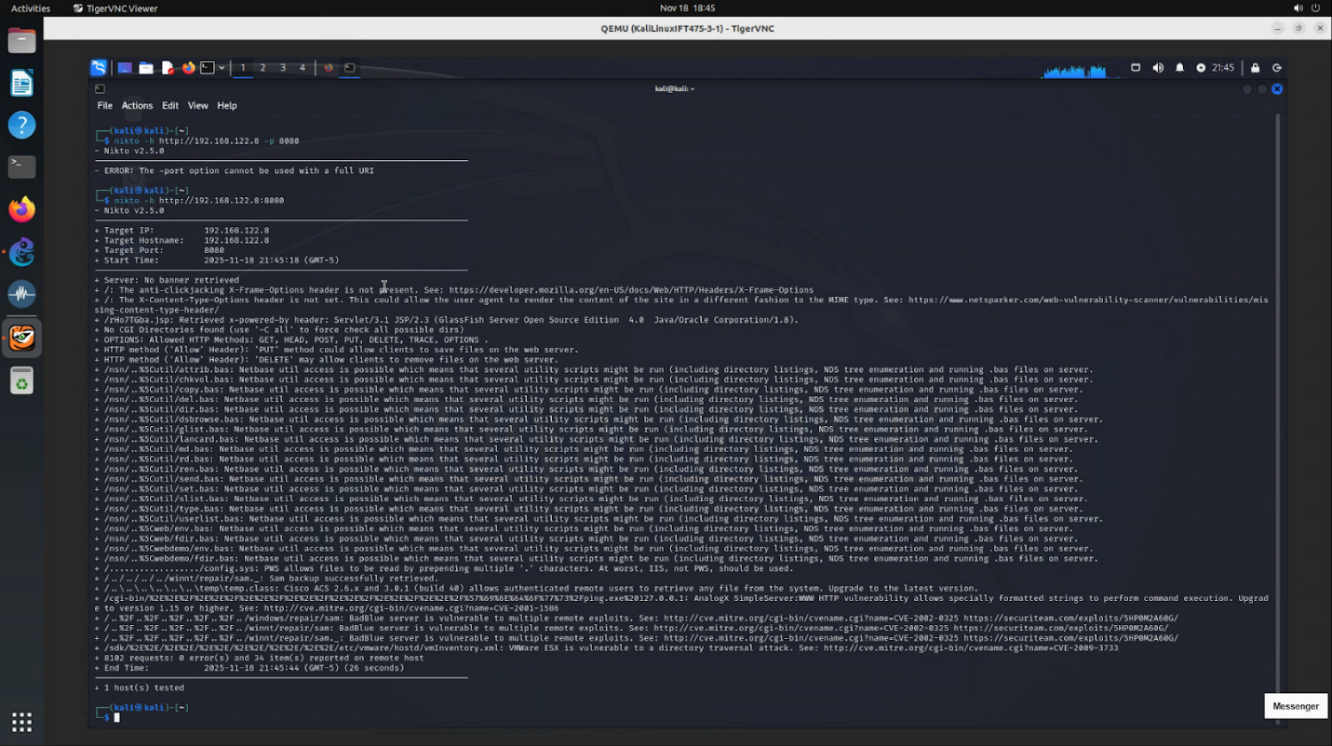

Figure 60: nikto -h <http://192>.168.122.8:8080

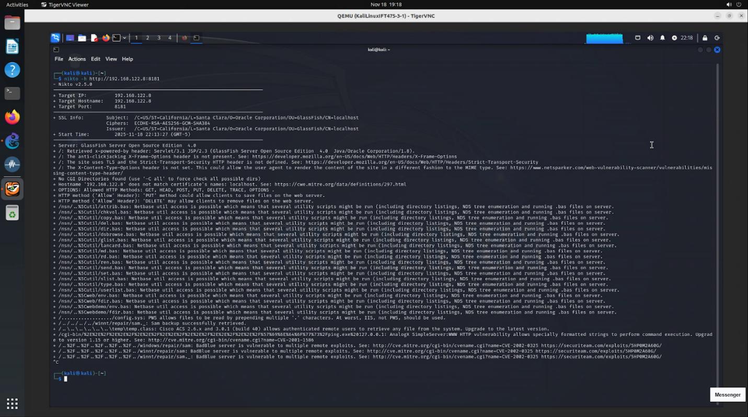

Figure 61: nikto -h <http://192>.168.122.8:8080

Finally, the service on port 8383 was running over HTTPS and tied to Zoho/ ManageEngine Desktop Central, confirmed by the SSL certificate. This service also lacked security headers and had a hostname mismatch in the certificate, which indicates it’s using a default or self-signed certificate rather than a properly configured one (Cloudflare, 2025).

  The Nikto results show that all exposed web services share a similar issue, outdated software and missing security hardening. While none of the findings alone guarantee an exploit, the combination of weak configurations, unnecessary HTTP methods, and older server versions significantly increases the attack surface and will be investigated further with Nessus.

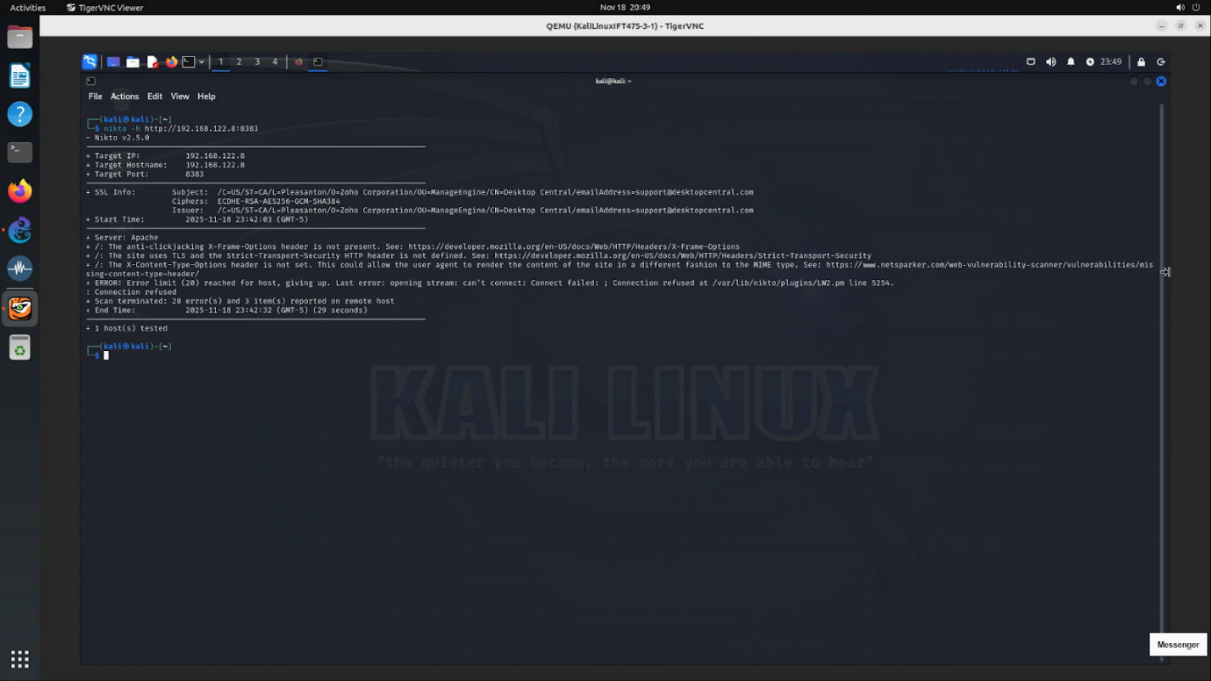

Figure 62: nikto -h <http://192>.168.122.8:8383

Across the dozens of vulnerabilities identified on the Windows Server 2008 R2 server, the four selected findings clearly show how outdated and exposed the system is. The first major issue is Apache Tomcat 8.0.x End-of-Life, where the installed Tomcat version stopped receiving security updates back in 2018. Running unsupported software means any new vulnerabilities discovered in Tomcat will never be patched, leaving the server permanently at risk.

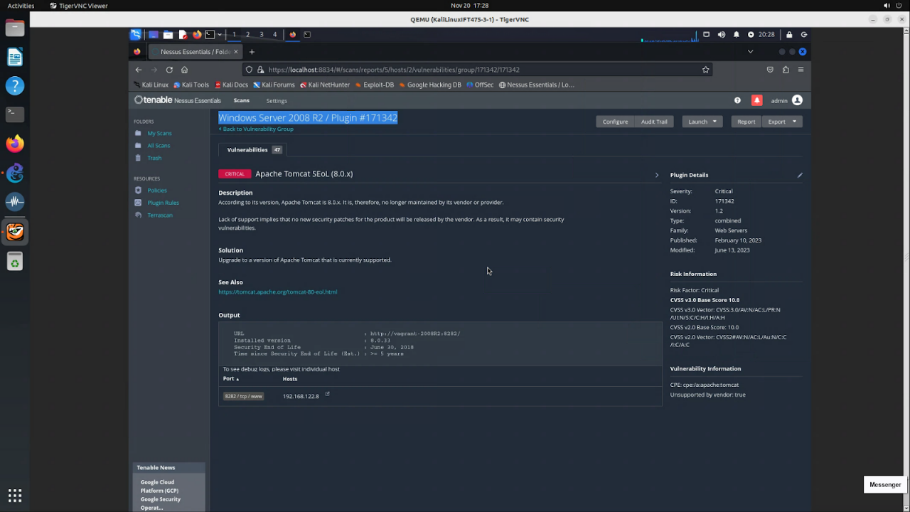

Figure 63: Nessus – Apache Tomcat Service End of Life

The second critical finding is MS11-030, a Windows DNS resolution vulnerability that can allow remote code execution under the NetworkService account. Even though this vulnerability is old, it is still extremely dangerous on unpatched systems like Windows Server 2008 R2 because it can be exploited remotely without credentials.

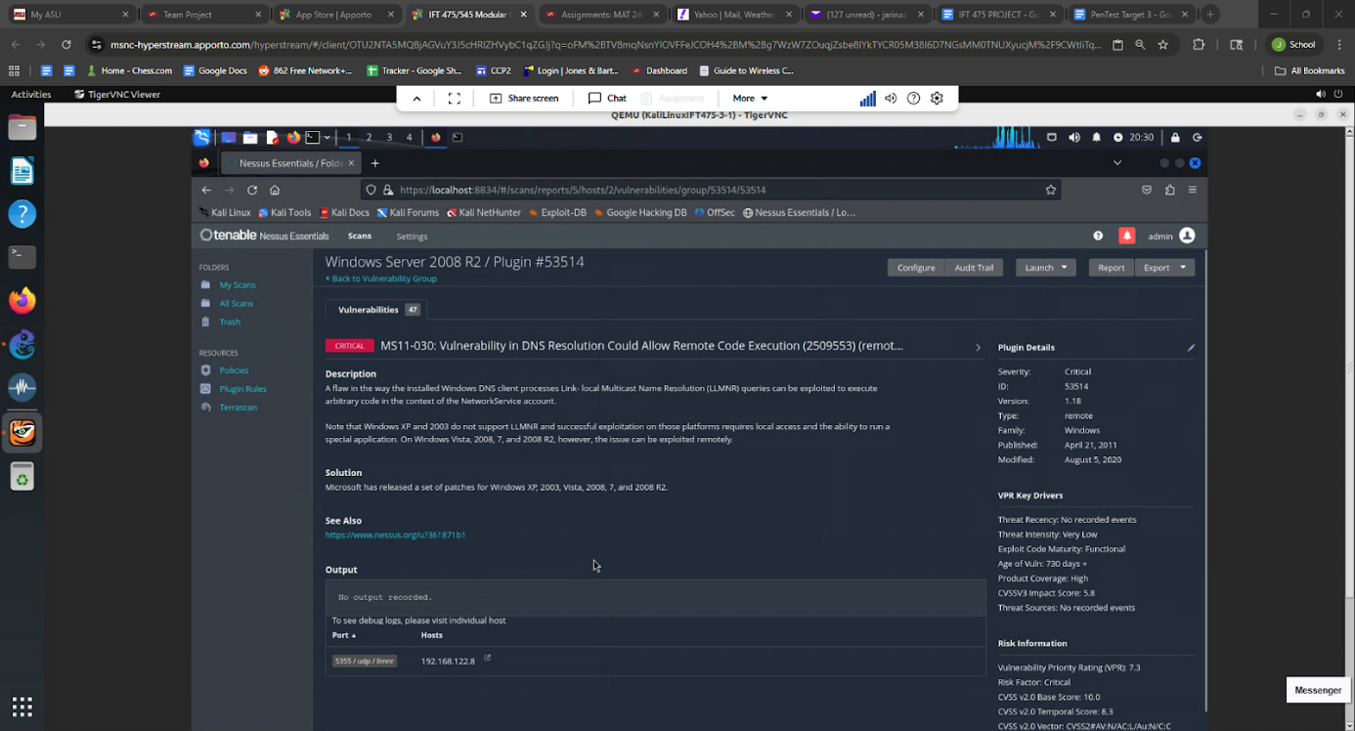

Figure 64: Nessus – MS11-030 Vulnerability in DNS Resolution

Nessus also flagged Apache httpd 2.1.x–2.2.x End-of-Life, which is another unsupported component. Like Tomcat, this version of Apache no longer receives updates, meaning it may contain multiple known vulnerabilities. The combination of outdated Tomcat and Apache builds on the same host highlights the overall lack of patching and maintenance.

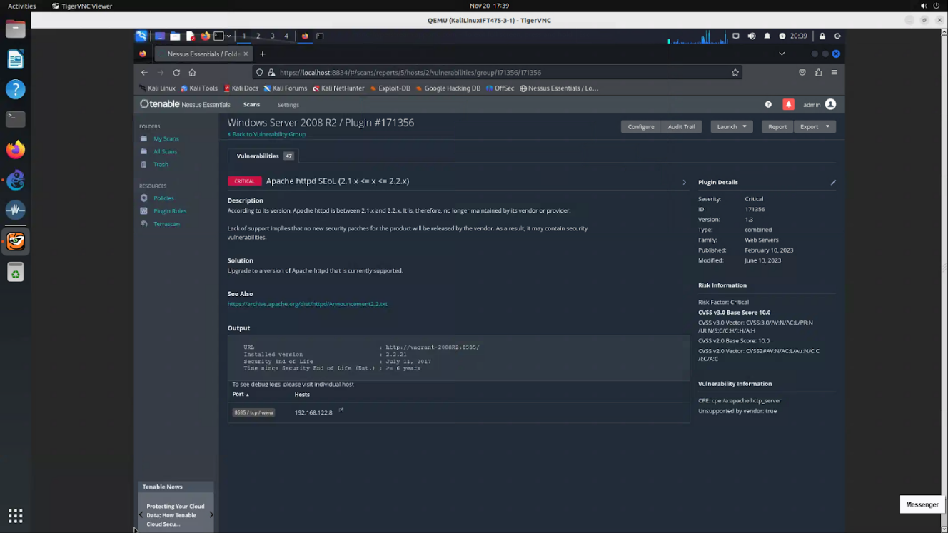

Figure 65: Nessus – Apache httpd 2.1.x–2.2.x End of Life

Finally, the scan identified SWEET32 medium-strength SSL ciphers, which means the server still allows older 64-bit block ciphers that are vulnerable to attack on long-lived or repeated sessions. While SWEET32 is less severe than the other findings, it still shows the server is using weak cryptographic settings that should have been phased out years ago (Bhargavan & Leurent, 2016).

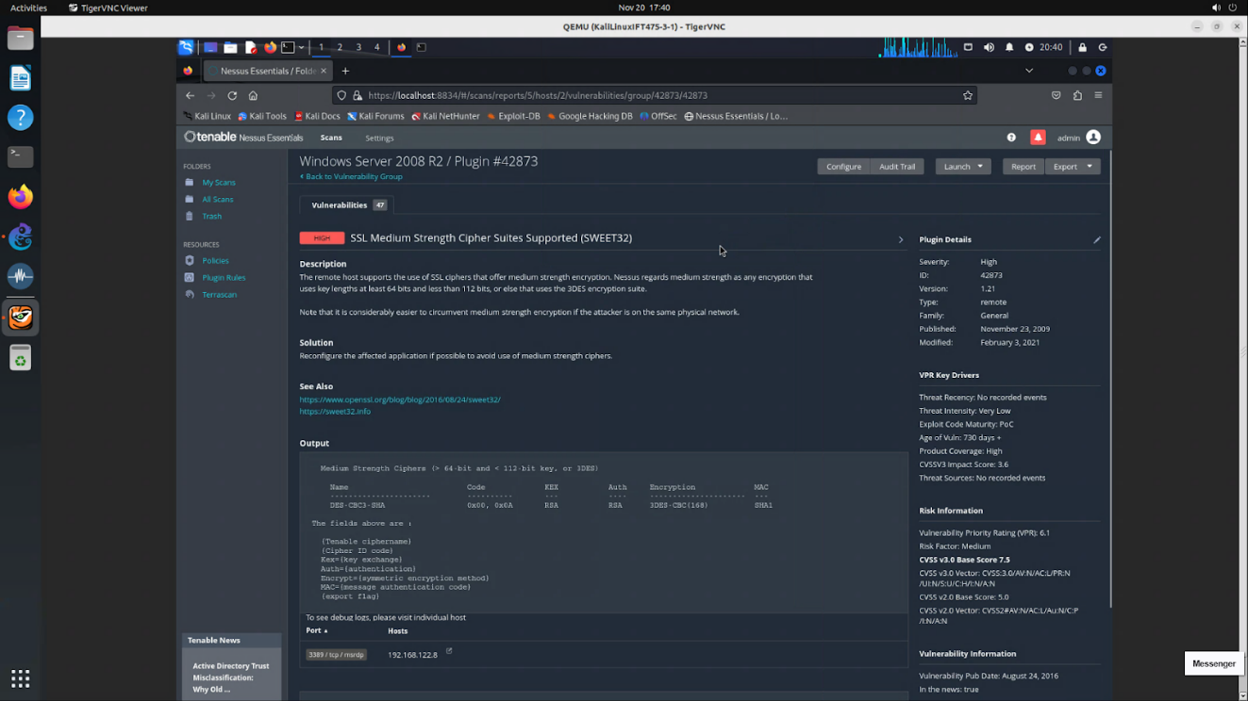

Figure 66: SSL Medium Strength Cipher Suites(Sweet32)

# **Recommendations**

It is imperative that CarGurus understands the risks associated with having such a publicly visible digital footprint. While transparency is required for the company as it is publicly traded, the personal information of their executive leadership team is not. Having a wealth of information published to a consolidated service like TruePeopleSearch greatly increases the attack landscape. No credible justification exists for exposing private contact information, including emails, phone numbers, addresses, and information about relatives or close associates. To remediate this, we suggest using a data removal service like Incogni or DeleteMe for each executive, as well as their family members. These services, while not free, allow for scrubbing of personal information from third party data broker sites and will greatly reduce the likelihood of a successful social engineering attack. Since the process of data scrubbing takes time, it is also recommended to provide extensive training for each executive on how to spot potential phishing, spear phishing, and other social engineering attacks.

While performing Google Hacking and using advanced search queries, we found internal company documentation, including PDFs and Excel spreadsheets that contained human resources information, like performance metrics for executives, payouts, bonus information, stock information, severance information, and much more. To remediate, the company should immediately restrict public access to any exposed files, ensuring that internal documents require authenticated, role-based permissions. Search engine indexing should be disabled through updated robots.txt rules and appropriate noindex tags, followed by formal removal requests to eliminate the documents from search results and cached pages. The organization should also review access logs to evaluate the scope of potential data exposure and identify any unauthorized downloads, as well as document handling policies and provide targeted employee training to prevent unintentional publication of sensitive content in the future, strengthening the company’s overall security posture.

To better protect themselves against insider threats, it is advisable that CarGurus enact strict protocols regarding the safeguarding of on-site network architecture as well as implementing some kind of permissions restriction regarding their users. This could be accomplished by implementing the principle of least privilege or a zero-trust model for user authentication. The principle of least privilege restricts user access to systems and applications based upon the minimum permissions required for a user to complete the task they’ve been assigned. A zero-trust authentication model forces a user to verify their credentials with every login, regardless of device, permission or application. By implementing these principles and protocols, CarGurus may better protect themselves against insider threats.

For Server 1, despite the strong foundational security posture found on the server, a series of recommendations can be made to help further improve system security: enforcing MFA for all administrative accounts, disabling SMBv1 and enabling SMB signing, restricting authentication to LDAPS, disabling anonymous LDAP binds, limiting RPC access only to authorized administrative hosts, segmenting domain controllers into isolated VLANs, implementing strict Kerberos policies like pre-authentication and delegation controls, reducing unnecessary exposure of services, timely installation of security patches, applying strong password policies to service accounts, and disabling all unused services not operationally required, such as port 42. In the end, the penetration testing process established that Server1 is indeed a Windows Active Directory Domain Controller securely configured to block any attempts at unauthorized access. While several critical services are open by design due to the purpose of the system, Server1 has very strong defensive controls and a very mature baseline security posture. It is recommended that continued hardening of the environment be performed, with better protection of credentials and network segmentation to decrease the associated risks with credential theft and lateral movement.

For Server 2, the Nessus scan resulted in identifying a critical vulnerability named Debian OpenSSH/OpenSSL Package Random Number Generator. This vulnerability impacts all cryptographic keys in the system. Any attacker can easily reconstruct the private SSH key due to this vulnerability and it will allow them to impersonate the server, decrypt past and future SSH, and also perform man-in-the-middle attacks. The recommendation to solve this vulnerability is to delete all existing SSH host keys then regenerate it using ssh-keygen -A and lastly to update clients. Also to make it a habit in ensuring updating and patching the system. Since the vulnerability was identified it is also a good posture to audit the system for unauthorized access by reviewing authentication logs and ssh login history. It also identified critical vulnerability named NFS Exported Share Information Disclosure. This vulnerability allows an attacker to gain access to credentials, internal applications, and configurations. With this vulnerability comes along the risk of losing or getting tampered data. The recommendation to solve this vulnerability is to only allow NFS export access for authorized users only. Ensure root_squash to prevent remote users from having root privileges. Make sure to implement a firewall as well to help make sure the traffic is not untrusted. Reviewing the current permissions or read/write in the system is also necessary. Another vulnerability found is VNC Server ‘password’ Password. This vulnerability allows an attacker to be able to execute commands, install malware, and extract files. In essence this vulnerability basically gives full access to a remote attacker. The recommendation to solve this vulnerability is to replace all passwords with at least 12+ characters, use a combination of lowercase and uppercase letters, do not use personal words or numbers, and lastly if possible to set a lockout policy.

For Server 3, based on the four key vulnerabilities identified in the Nessus scan, the following remediation steps are recommended for the Window 2008 R2 server. These issues primarily stem from outdated software, missing security patches, and weak encryption settings, all of which significantly increase the attack surface of the system. Apache Tomcat 8.0.x reached end-of-life on June 30, 2018, meaning it no longer receives security updates. Running unsupported Tomcat versions leaves the server exposed to serious vulnerabilities such as Ghostcat (CVE-2020-1938) and other remote code execution paths. Tomcat should be upgraded to a supported release (8.5.x or 9.x/10.x), and unused Tomcat components should be removed entirely. CarGurus should also patch MS11-030. This Windows DNS client vulnerability allows remote code execution through malicious LLMNR responses. Because the target runs Windows Server 2008 R2, it remains exposed until this patch is applied. Link-Local Multicast Name Resolution (LLMNR) is a backup name resolution protocol used by Windows systems when DNS queries fail. Instead of contacting a DNS server, the system broadcasts the query to the local network to see if another device can answer it. While convenient, LLMNR is insecure because the responses are not authenticated. Installing the Microsoft update associated with CVE-2011-0657 and disabling LLMNR will eliminate this attack vulnerability. Apache httpd 2.2 has been out of support since 2017, leaving it vulnerable to several historical issues. Including CVE-2011-3192, CVE-2012-0053, and CVE-2013-1862.It has no ongoing security updates. Upgrading to Apache 2.4.x is recommended to ensure continued security patching and improved configuration options.

# **Conclusion**

Overall, this assessment illustrates that while CarGurus has implemented strong security controls in some areas, most notably Server 1, significant weaknesses remain across the organization’s server infrastructure, digital footprint, and internal documentation practices. The information discovered through OSINT and the overly permissive document sharing create substantial opportunities for social engineering attacks that target both executives and employees. The technical vulnerabilities found on Servers 2 and 3 underscore the risks associated with outdated systems, weak encryption configurations, insufficient path management, and misconfigured services.

Mitigating these risks requires a combination of technical and strategic improvements, including stricter access controls, stronger authentication requirements, removal of executive personal data from third-party data-broker platforms, improved document handling practices, and comprehensive remediation of all identified server vulnerabilities. Implementation of zero-trust principles, proper segmentation, and least privilege permissions will greatly reduce the attack landscape and surface, and limit possible lateral movement within the environment. By adopting these recommendations and prioritizing continuous modernization, hardening, and monitoring, CarGurus can significantly strengthen its security posture, reduce exposure to both external and insider threats, and better safeguard the confidentiality, integrity, and availability of its systems and sensitive information.

# **Annexes**

## **Annex A - References**

Bhargavan, K., & Leurent, G. (2016). Sweet32: Birthday attacks on 64-bit block ciphers in TLS and OpenVPN. https://sweet32.info/

CarGurus. (2020). CarGurus acquires car shopping platform Autolist. https://investors.cargurus.com/news-releases/news-release-details/cargurus-acquires-car-shopping-platform-autolist

CarGurus. (2023). CarGurus agrees to fully acquire CarOffer. https://investors.cargurus.com/news-releases/news-release-details/cargurus-agrees-fully-acquire-caroffer

CarGurus. (2024). Q4 2023 business update (pp. 1–32). https://investors.cargurus.com/static-files/511f3bc3-ac6b-43ca-92d8-9a4aa38f44a9

Cloudflare. (n.d.). What is a domain name registrar? https://www.cloudflare.com/learning/dns/glossary/what-is-a-domain-name-registrar/

Cloudflare. (2023). What is a content delivery network (CDN)? https://www.cloudflare.com/learning/cdn/what-is-a-cdn/

Cloudflare. (2025). SSL certificate errors and how to fix them. https://www.cloudflare.com/learning/ssl/common-errors/

OWASP. (2014, September). WSTG – v4.1. https://owasp.org/www-project-web-security-testing-guide/v41/4-Web_Application_Security_Testing/02-Configuration_and_Deployment_Management_Testing/06-Test_HTTP_Methods

OWASP. (2024). HTTP headers – OWASP cheat sheet series. https://cheatsheetseries.owasp.org/cheatsheets/HTTP_Headers_Cheat_Sheet.html

Spencer, G. (2025, August 8). Cargurus shuts down CarOffer 18 months after acquiring it. AIM Group. https://aimgroup.com/2025/08/08/cargurus-shuts-down-caroffer-18-months-after-acquiring-it/

TradingView. (2024, December 20). CarGurus executive chair Langley Steinert sells over $5.5 million in company stock. https://www.tradingview.com/news/tradingview:2ce449ce9a4af:0-cargurus-executive-chair-langley-steinert-sells-over-5-5-million-in-company-stock/

## **Annex B – Acronyms (in order as they appear)**

* **OSINT** - Open-Source Intelligence
* **USB** - Universal Serial Bus
* **SEC** - Securities and Exchange Commission
* **CEO** - Chief Executive Officer
* **CFO** - Chief Financial Officer
* **IP** - Internet Protocol
* **URL** - Uniform Resource Locator
* **DNS** - Domain Name System/ Domain Name Server
* **AWS** - Amazon Web Services
* **SSL** - Secure Socket Layer
* **SYN** - Synchronize
* **HTTP** - Hypertext Transfer Protocol
* **RPC** - Remote Procedure Call
* **NetBIOS** - Network Basic Input/Output System
* **LDAP** - Lightweight Directory Access Protocol
* **SMB** - Server Message Block
* **RPC over HTTP** - Remote Procedure Calls over Hypertext Transfer Protocol
* **LDAPS** - Lightweight Directory Access Protocol Secure
* **RDP** - Remote Desktop Protocol
* **FTP** - File Transfer Protocol
* **OS** - Operating System
* **SSH** - Secure Shell
* **TCP** - Transmission Control Protocol
* **SID** - Security Identifier
* **RID** - Relative ID
* **HTTPS** - Hypertext Transfer Protocol Secure
* **PDF** - Portable Document Format
* **VLAN** - Virtual Local Area Network
* **VNC** - Virtual Network Computing
* **LLMNR** - Link-Local Multicast Name Resolution

## **Annex C – Additional Images/Screenshots/Tables**

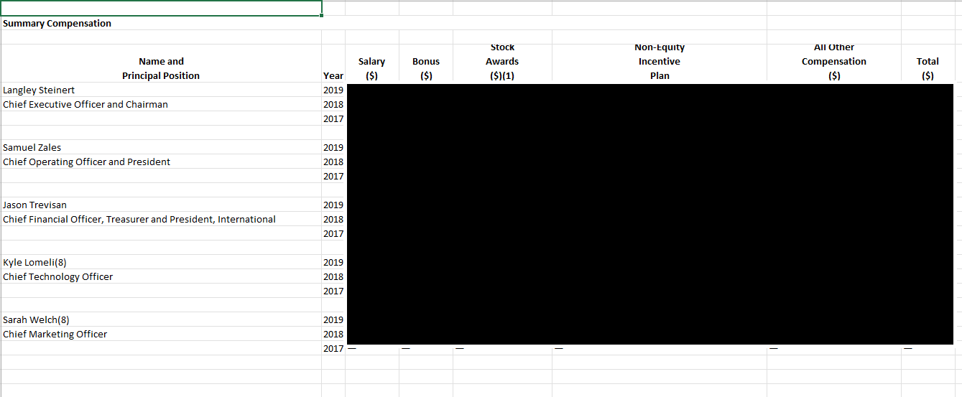

Figure 67: 2017 - 2019 Financial compensation data (blocked for privacy)

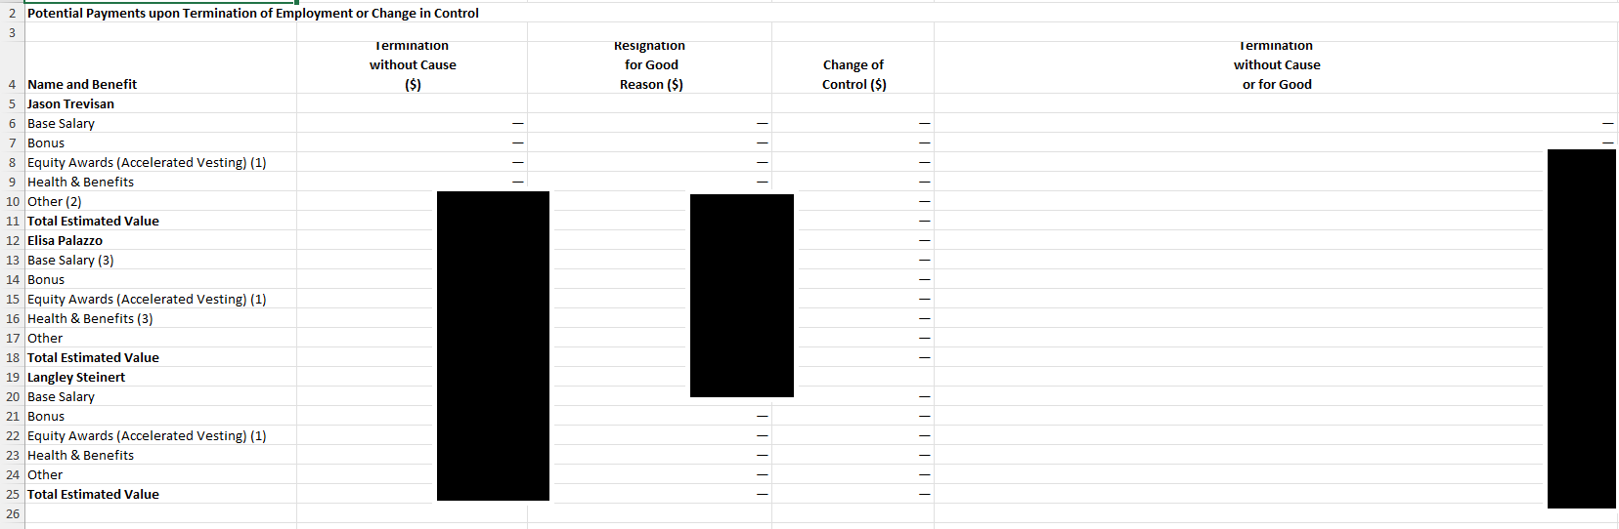

Figure 68: Trevisan severance package

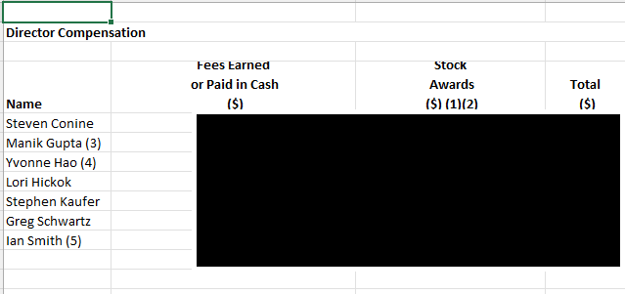

Figure 69: Director compensation

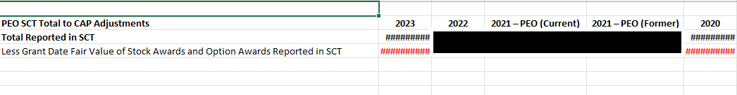

Figure 70: More internal documentation

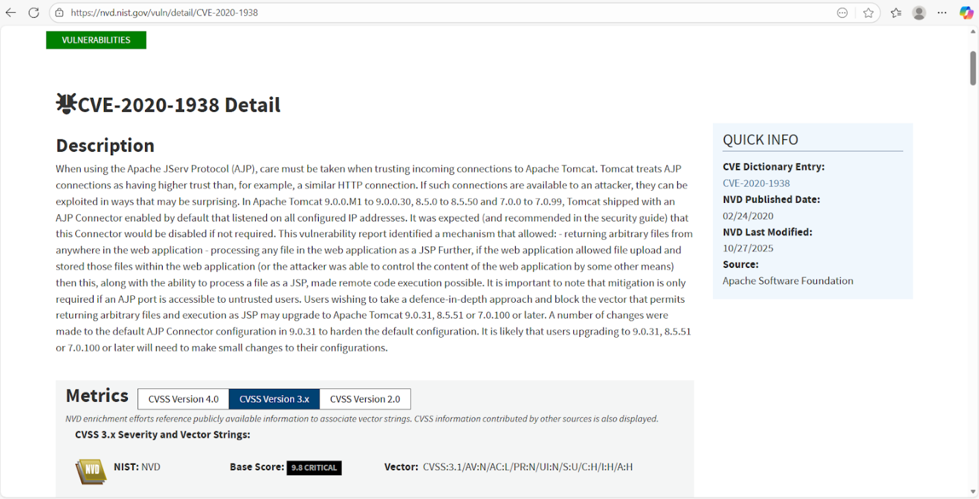

Figure 71: CVE-2020-1938

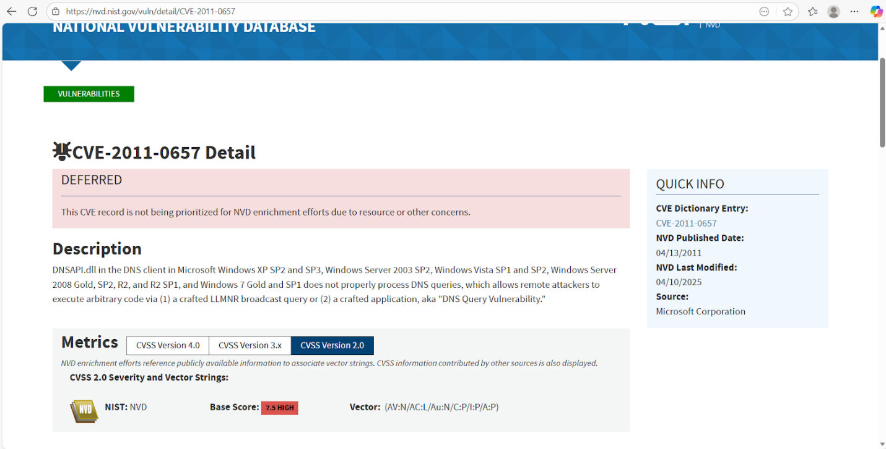

Figure 72: CVE-2011-0657

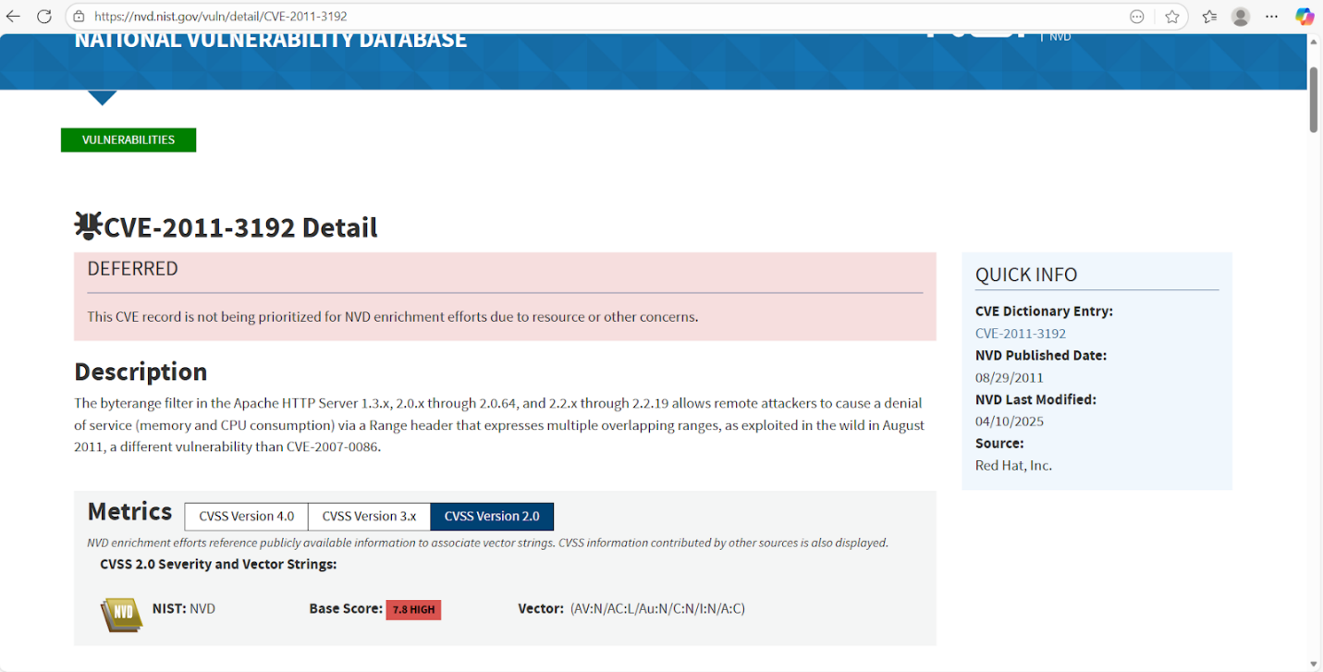

Figure 73: CVE-2011-3192

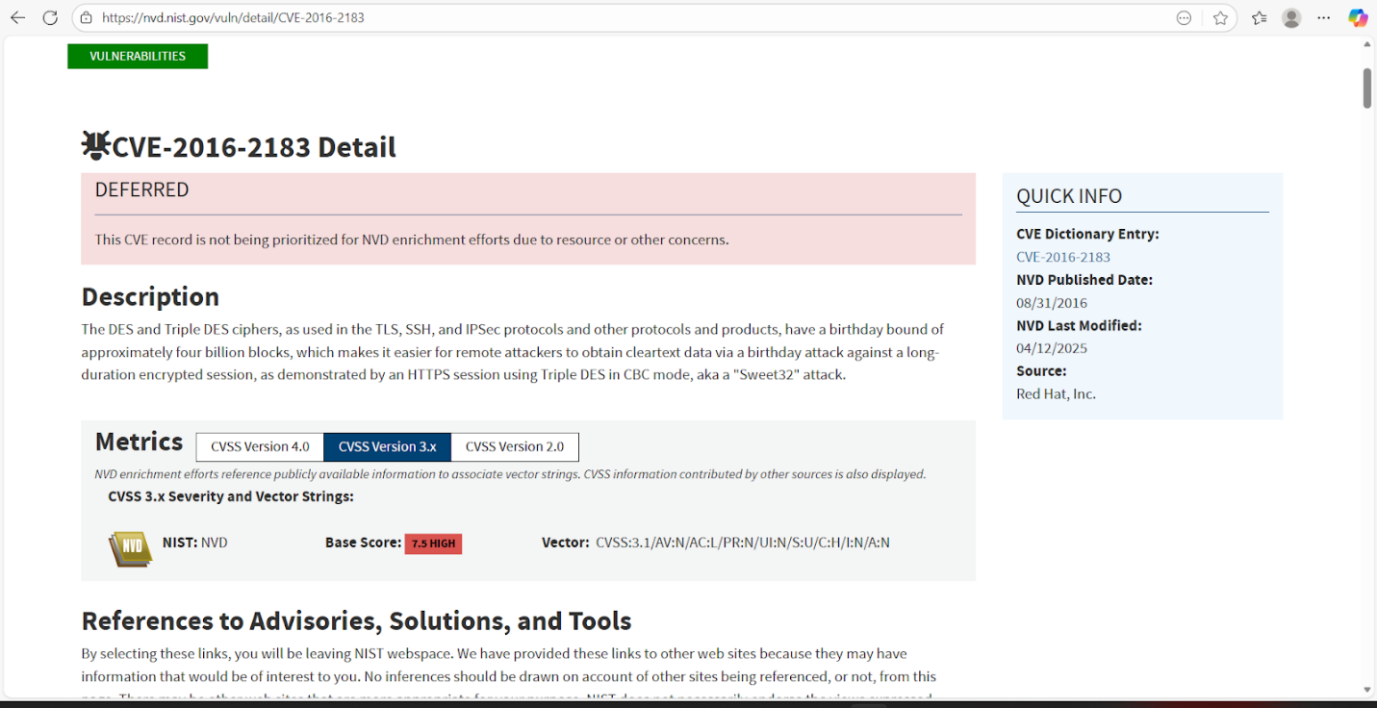

Figure 74: CVE-2016-2183

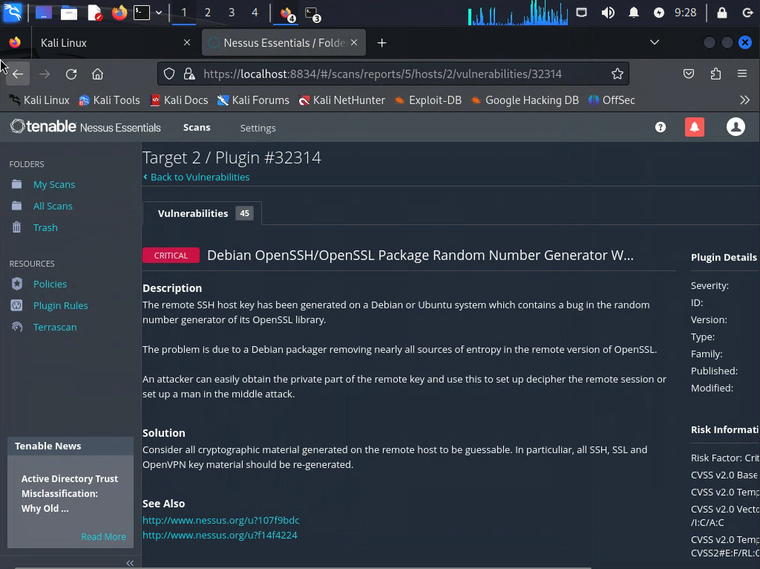

Figure 75: Debian OpenSSH/OpenSSL Package Random Number Generator

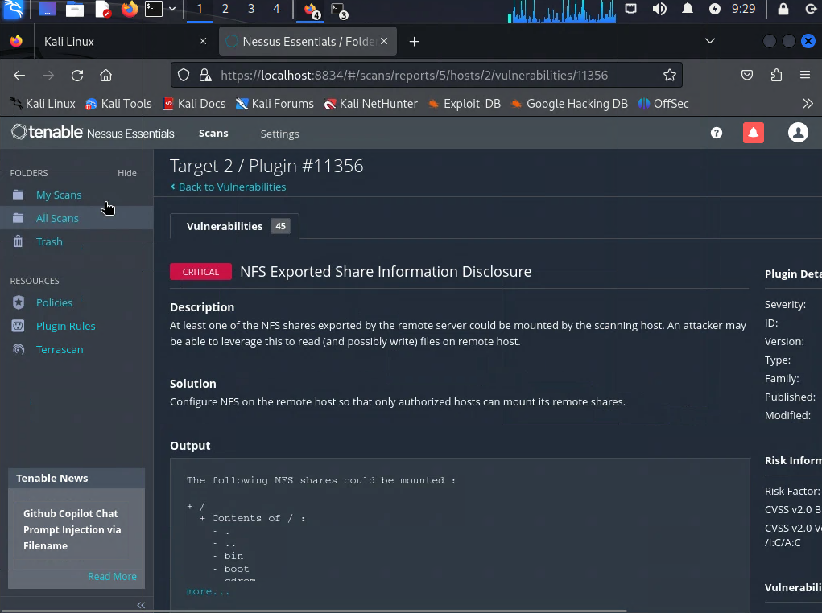

Figure 76: NFS Exported Share Information Disclosure

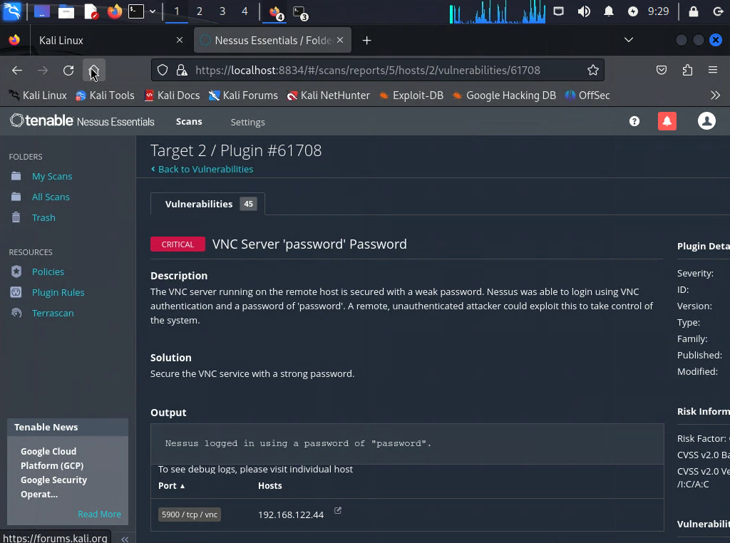

Figure 77: VNC Server ‘Password’ Password